**Node to-do app CICD pipeline**

**First code is provided by the developer. -** [**https://github.com/saparprayag/Node-todo-app.git**](https://github.com/saparprayag/Node-todo-app.git)

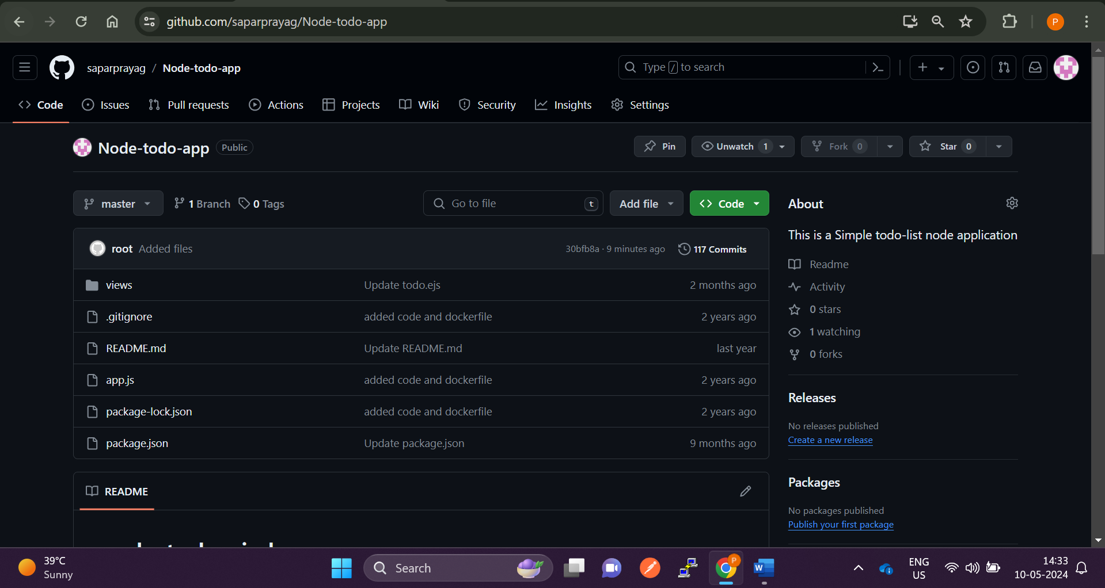

**Our job is to make the application run in any platform**

**We need to make sure that the application must run in any environment in integrated form. i.e irrespective of platform!**

**So the first toll we need is Docker and code we need is from github and we will run this code in AWS ec2**

**We need Jenkins to pull the code build it and delivery to the cloud.**

**In short we need to create a pipeline.**

**As a devops engineer we need to create a dockerfile and container the application so that we can use that application anywhere irrespective of the platform and delivery the dapplication continuously in the AWS cloud using Jenkins CICD**

**Tools we require Docker Jenkins Github AWS**

**First create a EC2 instance and connect the instance**

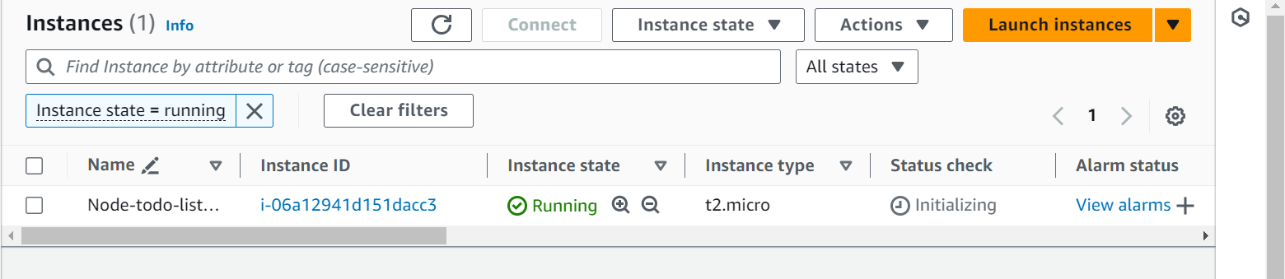

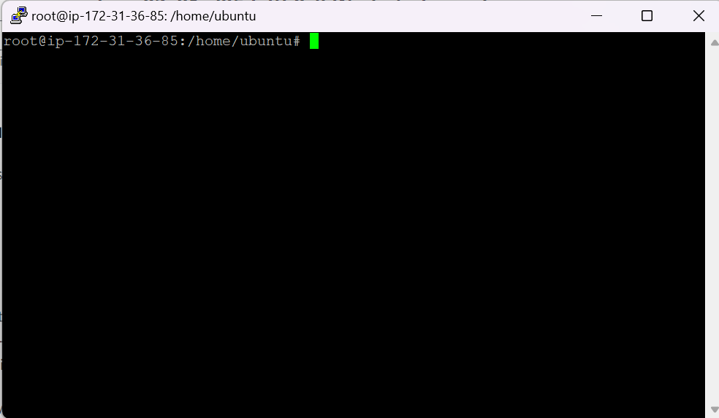

**Connect the instance using putty**

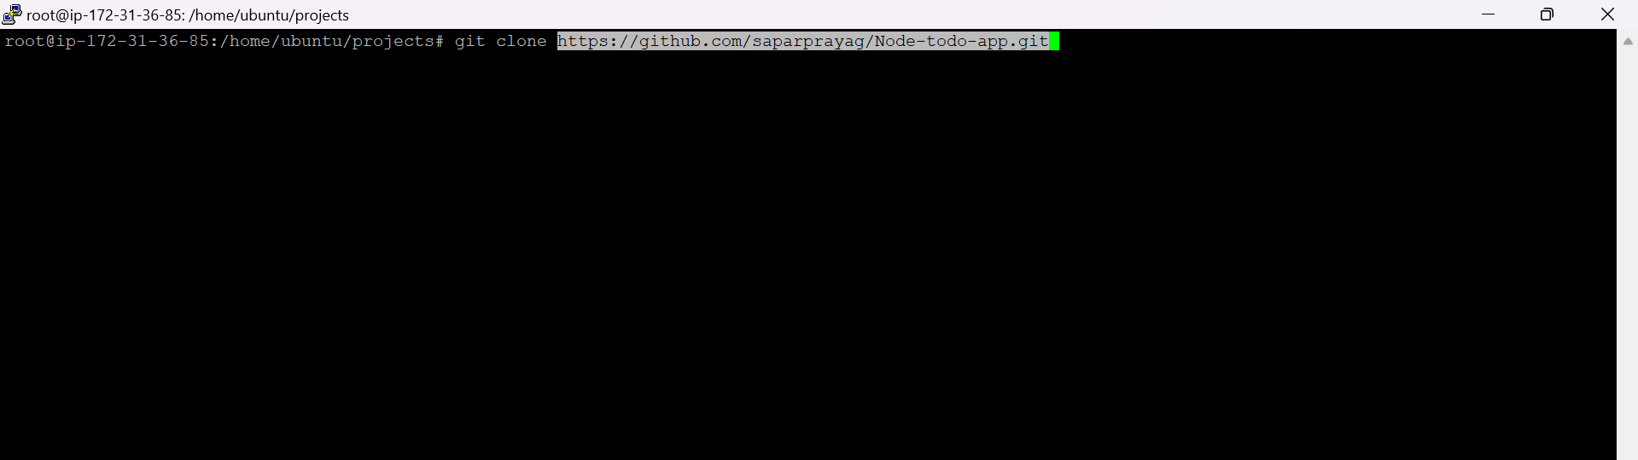

**Now clone the repository to the instance so that all the code gets copied in the aws instance**

**Command git clone** [**https://github.com/saparprayag/Node-todo-app.git**](https://github.com/saparprayag/Node-todo-app.git)

**sudo apt update -y**

**sudo apt upgrade -y**

**sudo apt install openjdk-17-jre -y**

**curl -fsSL https://pkg.jenkins.io/debian-stable/jenkins.io-2023.key | sudo tee \**

**/usr/share/keyrings/jenkins-keyring.asc > /dev/null**

**echo deb [signed-by=/usr/share/keyrings/jenkins-keyring.asc] \**

**https://pkg.jenkins.io/debian-stable binary/ | sudo tee \**

**/etc/apt/sources.list.d/jenkins.list > /dev/null**

**sudo apt-get update -y**

**sudo apt-get install jenkins -y**

**Now install Jenkins in order to create CICD pipeline paste the above commands**

**And go to security groups and enable port 8080 in order to access the Jenkins… like this**

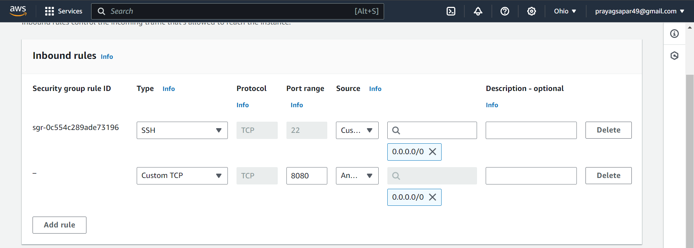

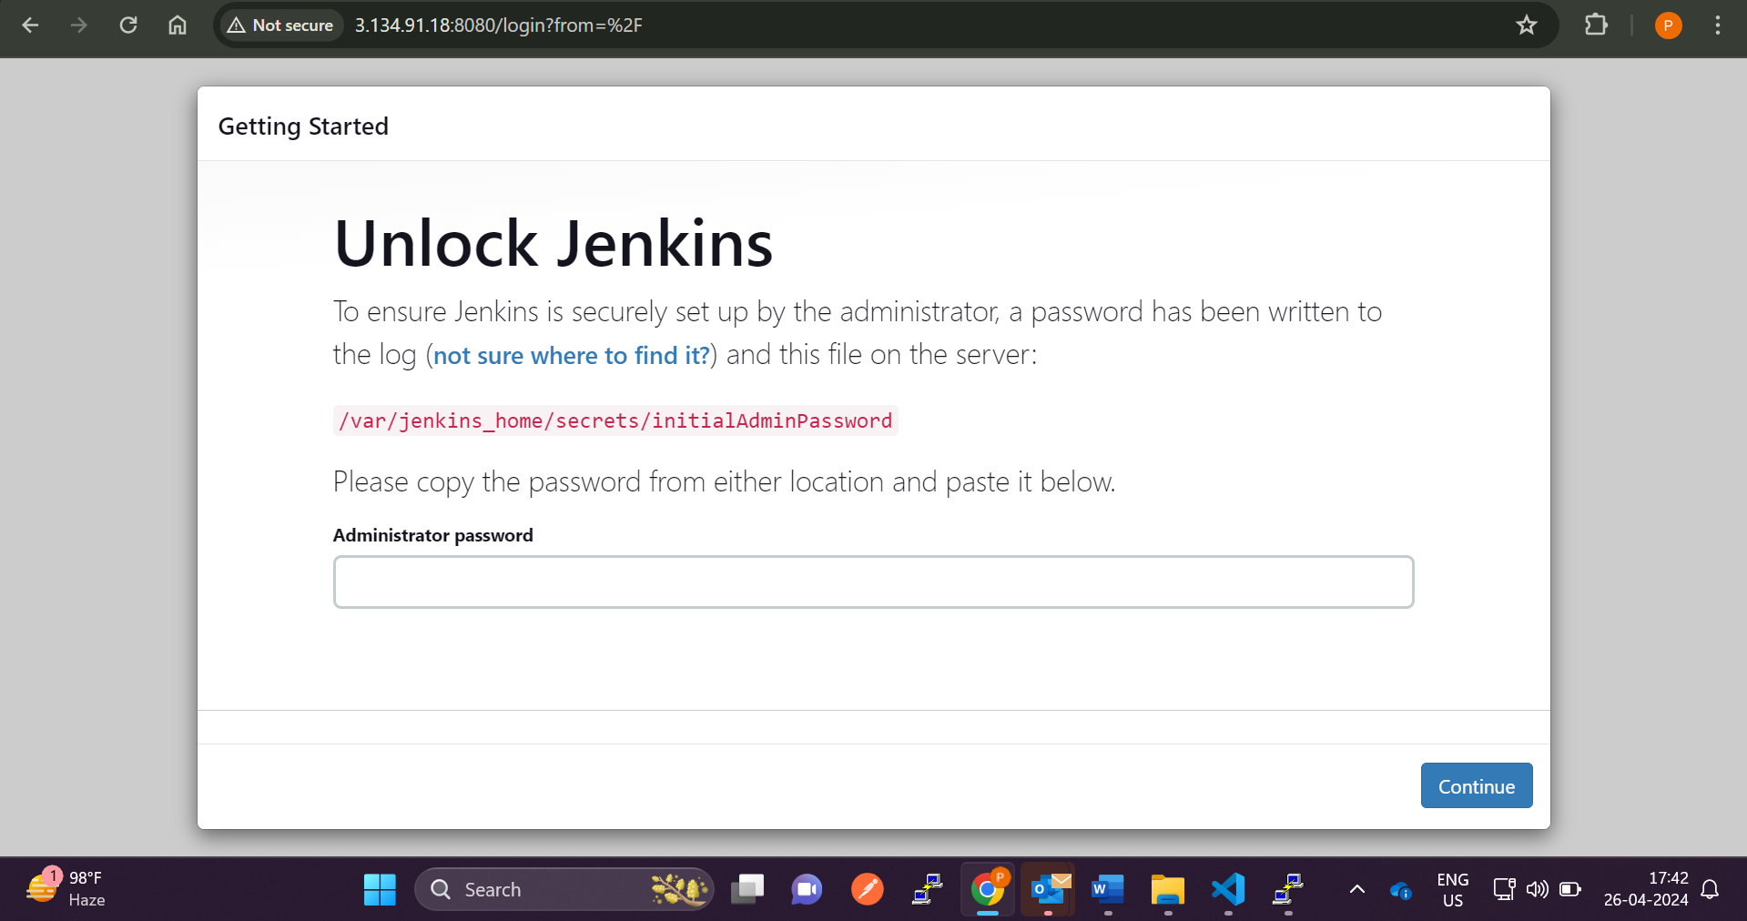

**cat** /var/lib/jenkins/secrets/initialAdminPassword in aws ec2

copy the password and paste it in Administrator password

To get the password and unlock the Jenkins

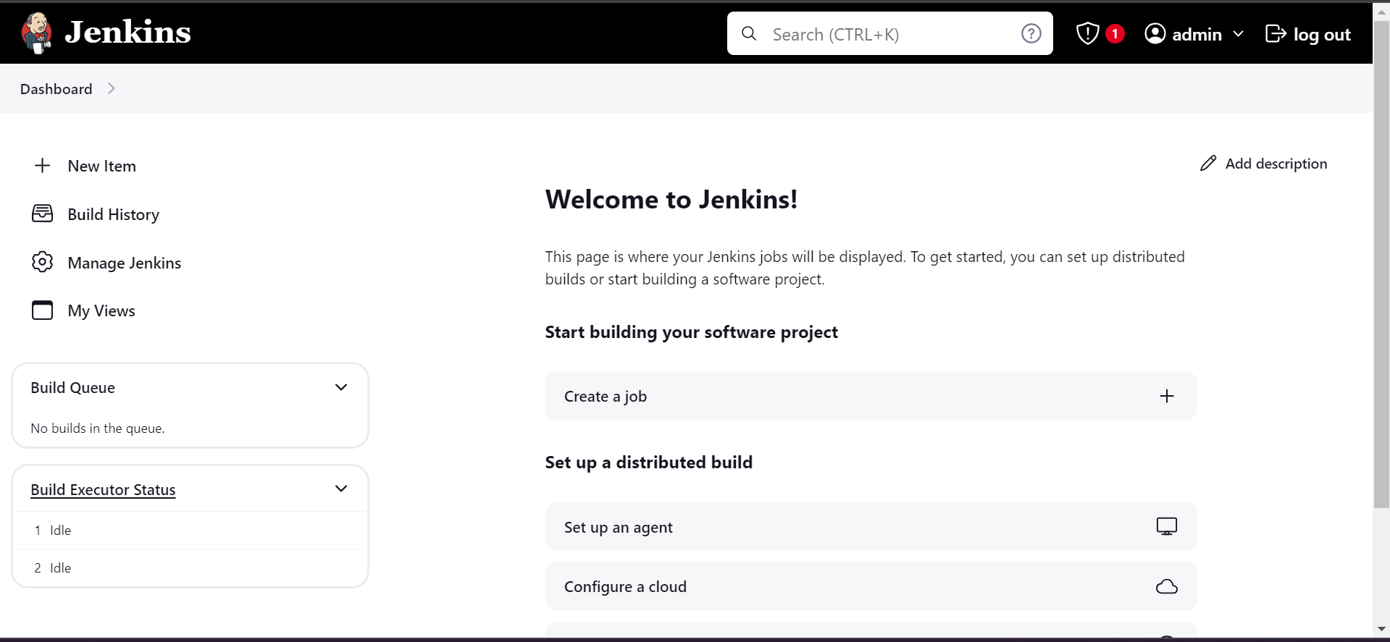

**Jenkins is now setup successfully … here we can create a CICD pipeline**

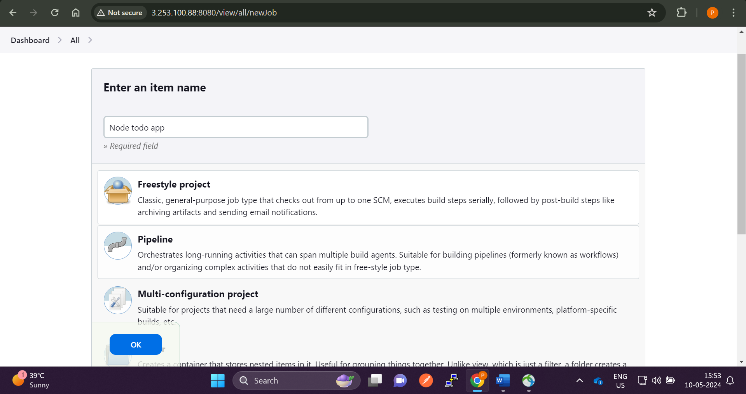

**Click on new item -> select a freestyle project and click ok**

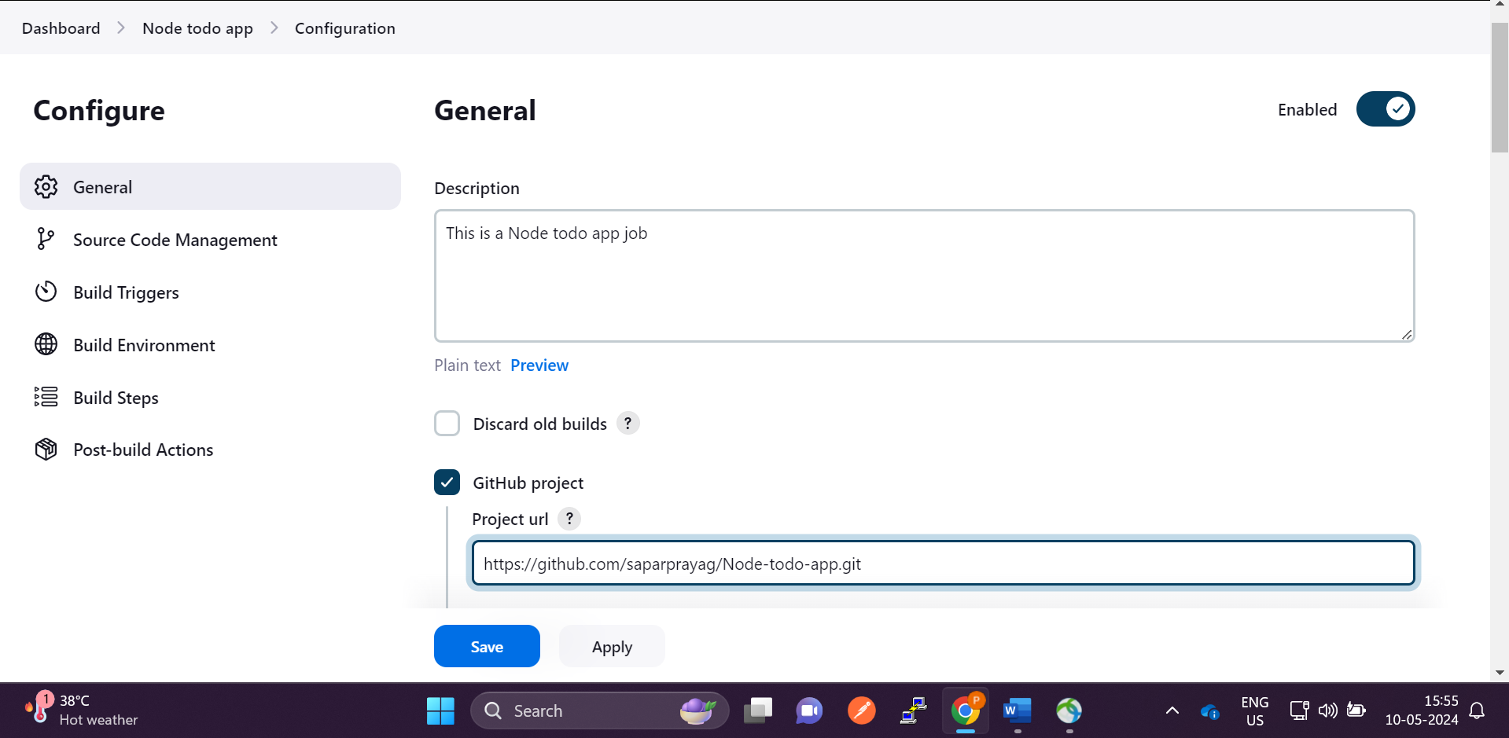

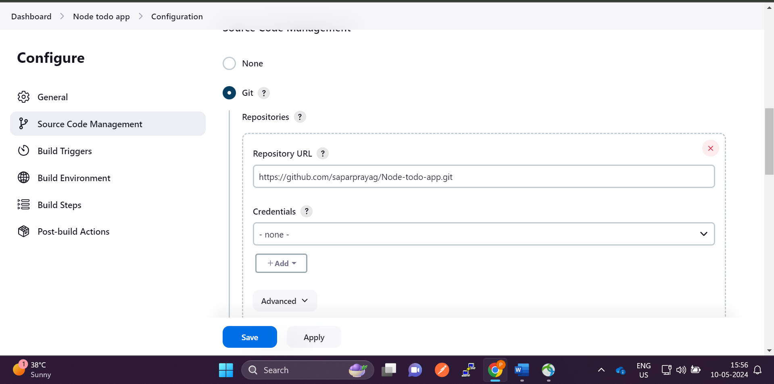

**Give the Description and github url from where the code will be pulled by Jenkins**

**Now we need to configure Jenkins and github**

**We will establish connection using ssh to configure Jenkins and github**

**Go to the server and type command ssh-keygen to create public and private keys**

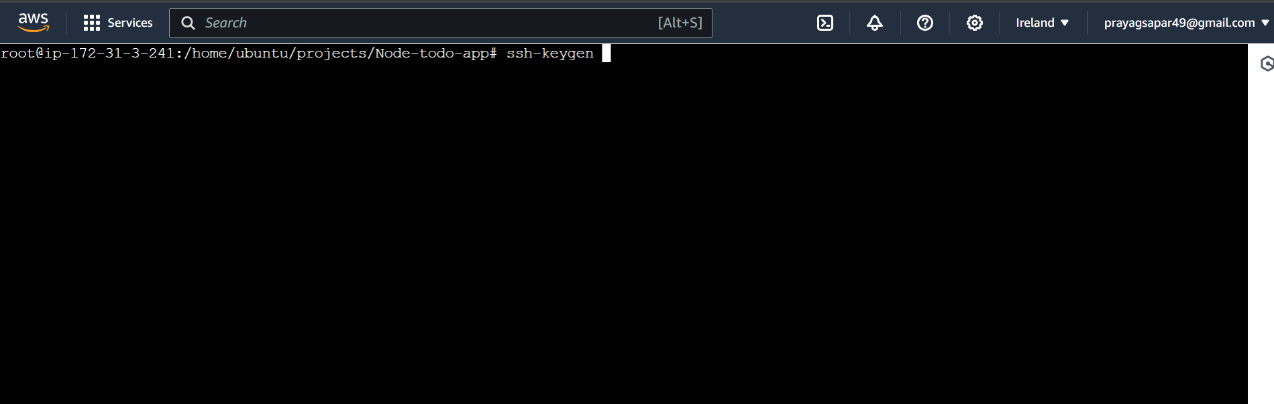

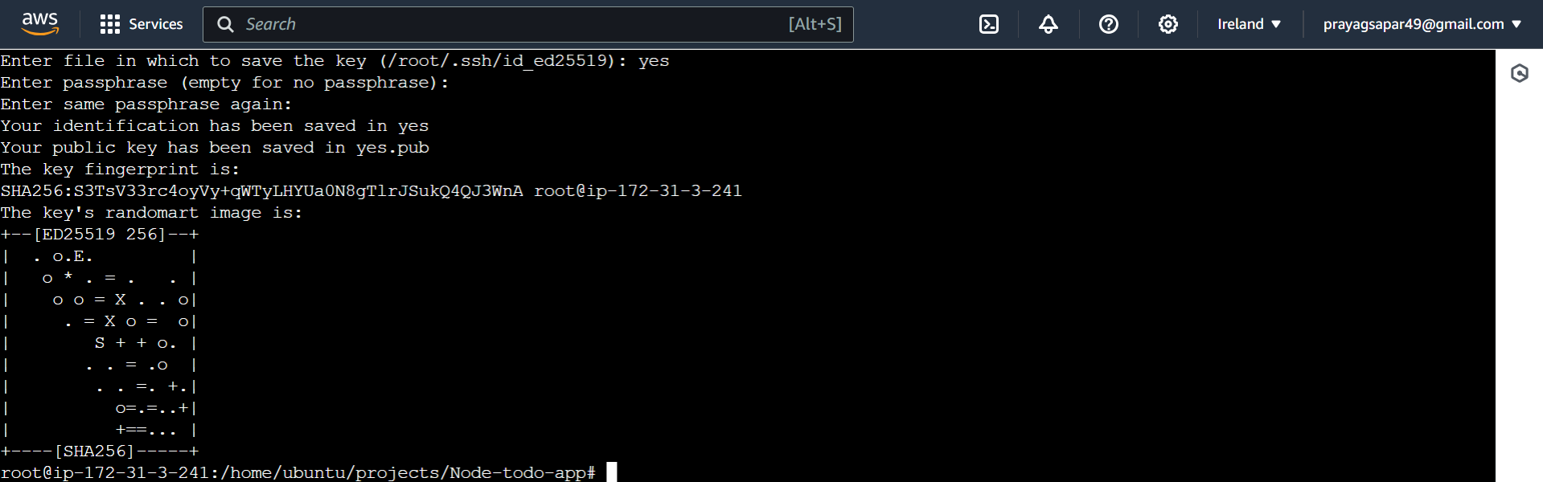

**Now public keys and private keys are created**

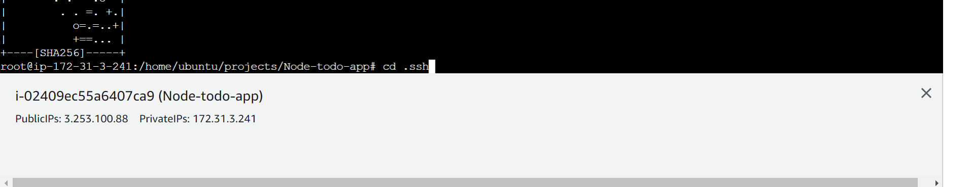

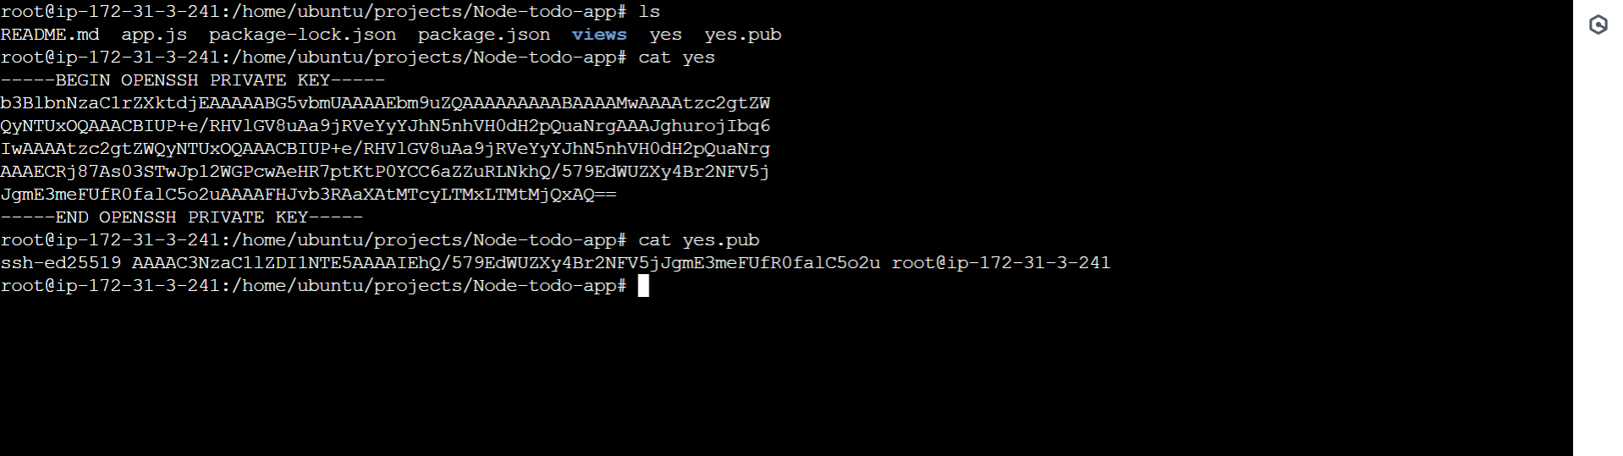

**Here yes is the private key and yes.pub is public key**

**Now we will connect github with the server using public key and Jenkins with server using private key**

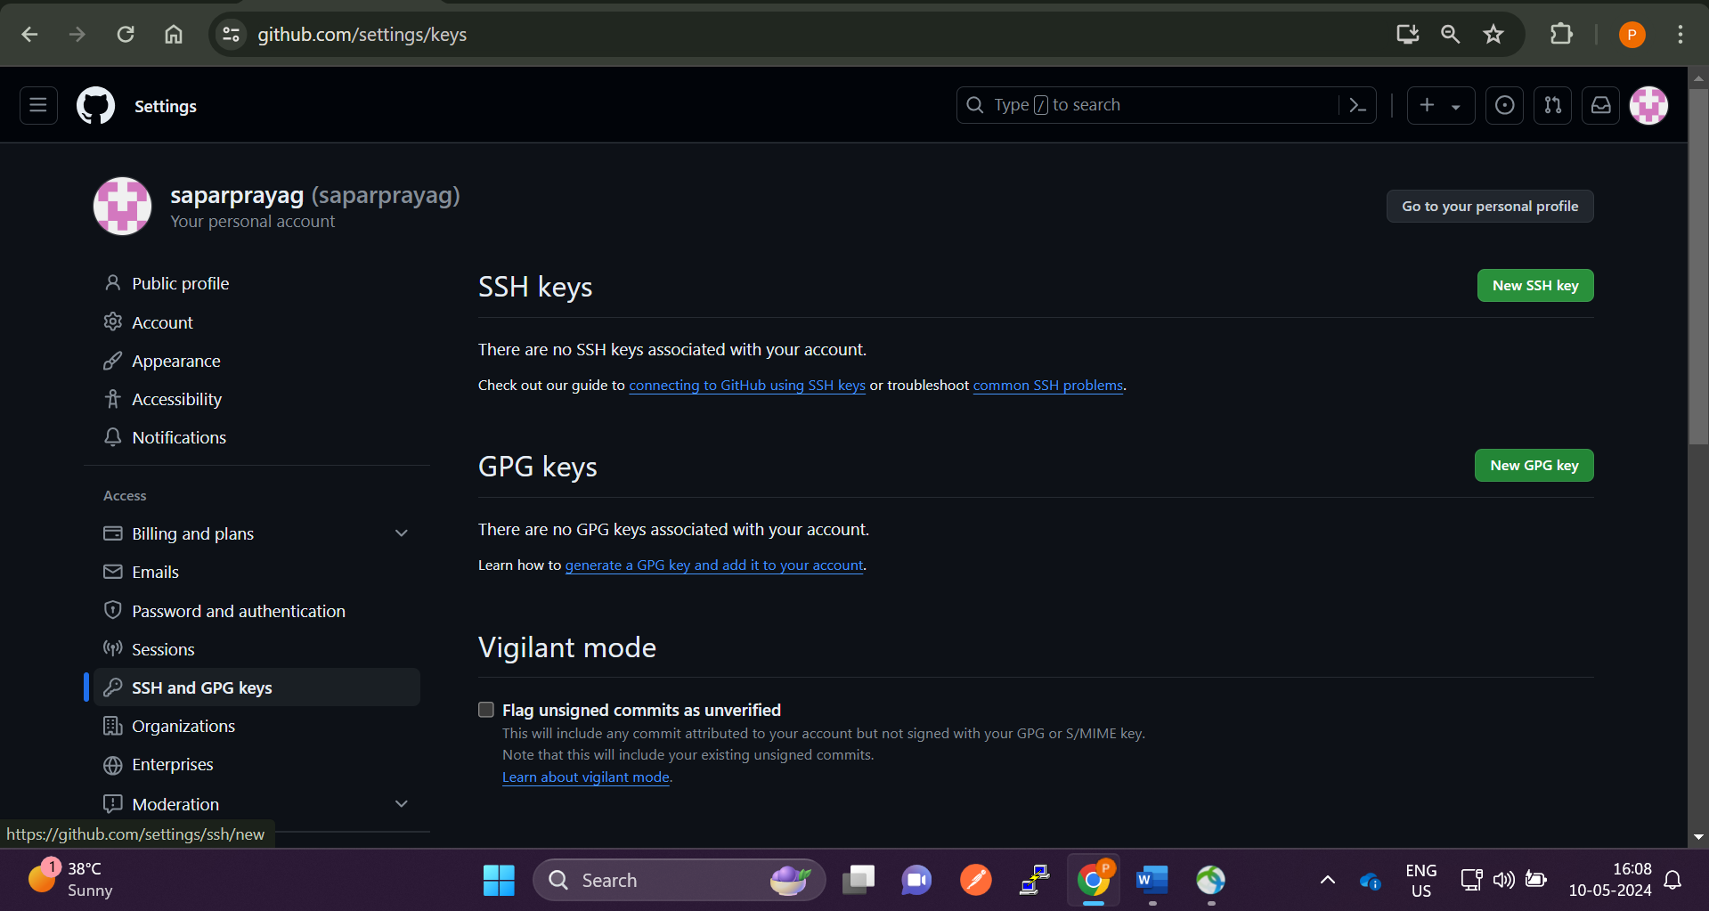

**Go to github settings and click on SSH and GPG keys and click on new ssh keys**

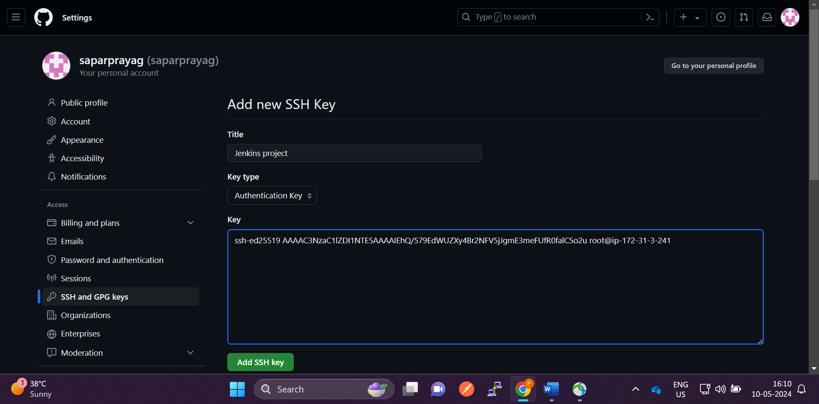

**Click on add ssh keys and paste the public key**

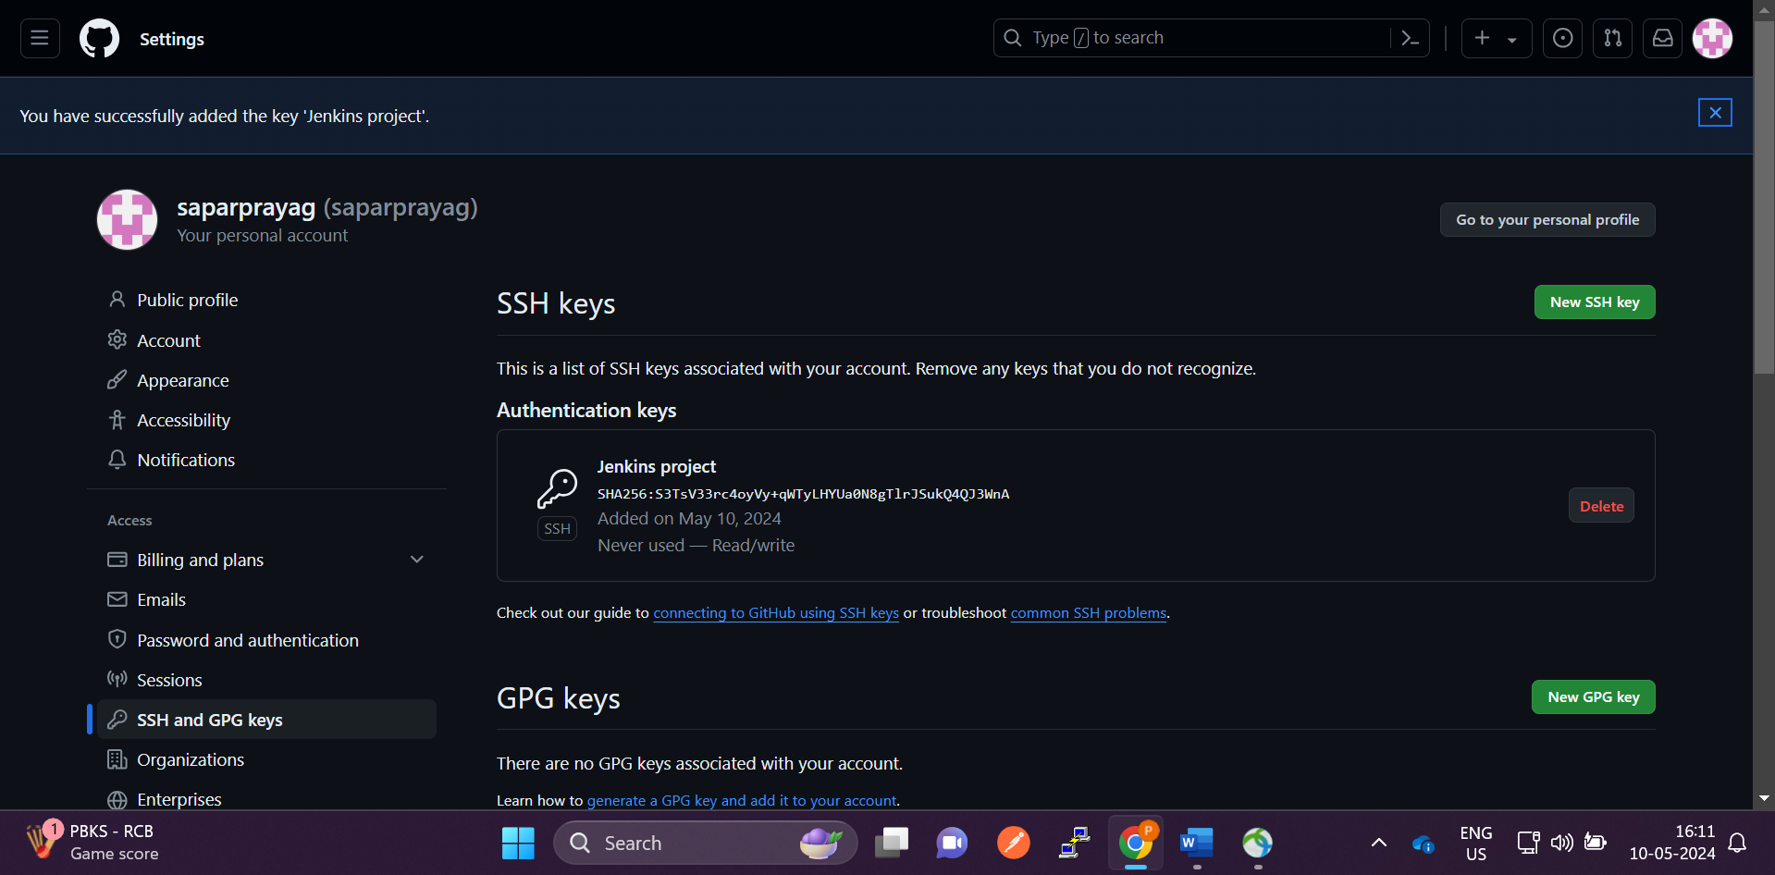

**Ssh keys successfully added**

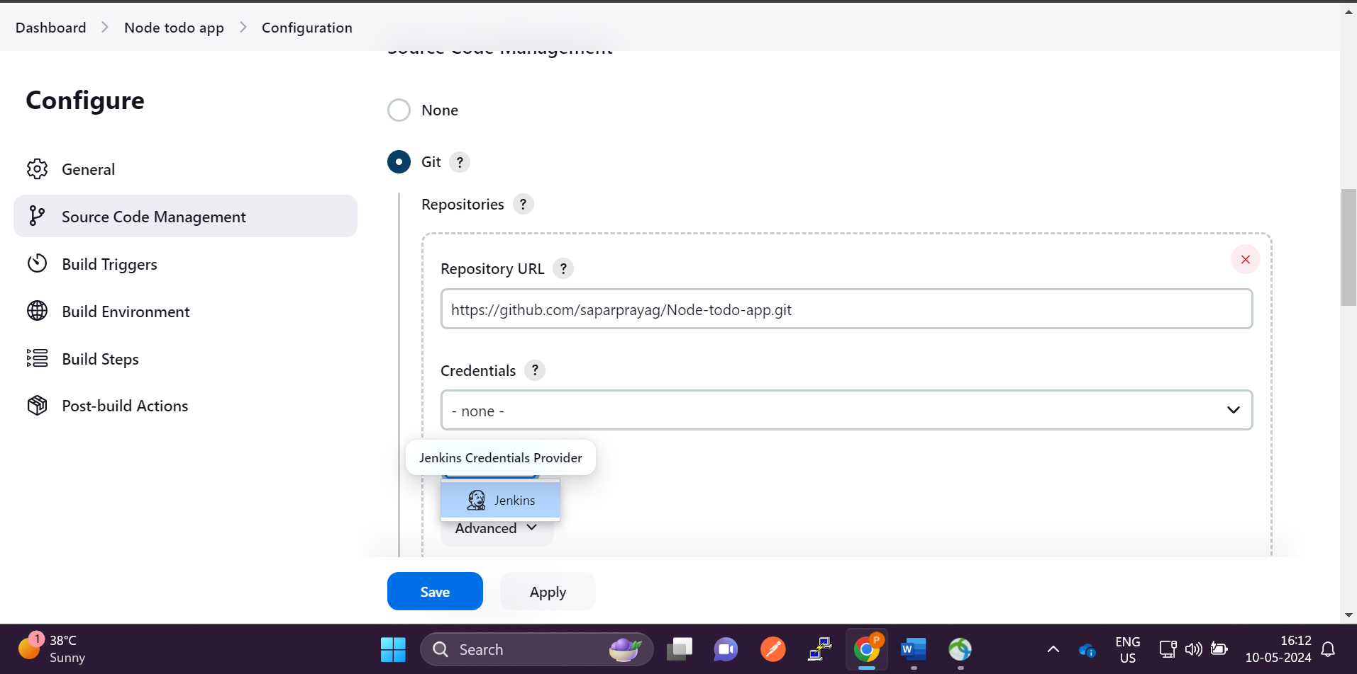

**Now click on add credentials**

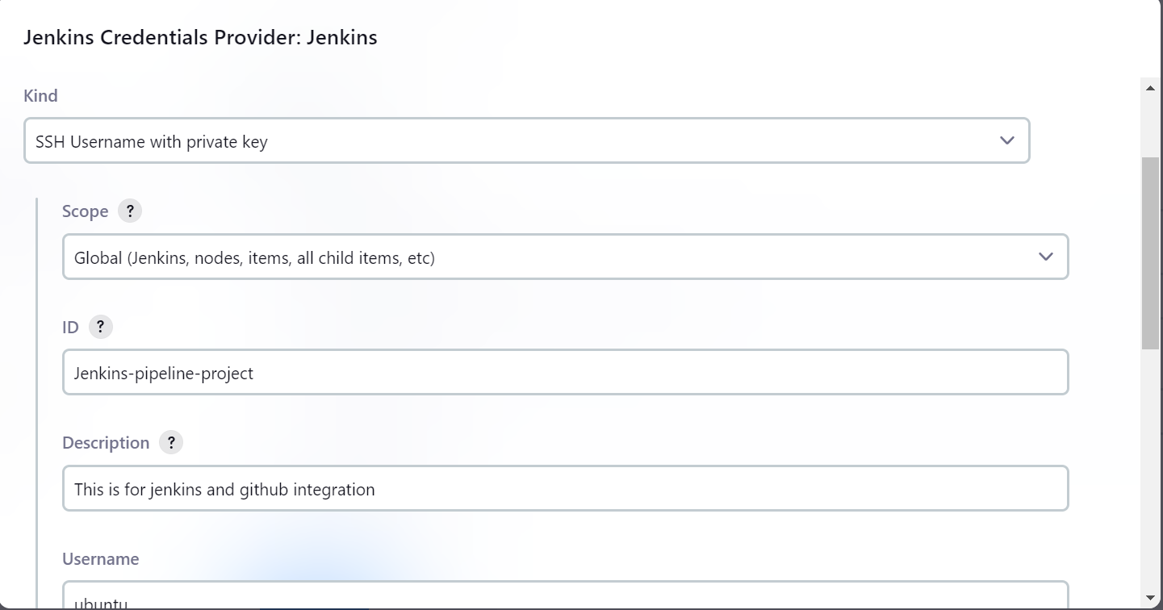

**Select the ssh and paste the private keys**

**Give the Id description username in this case is ubuntu**

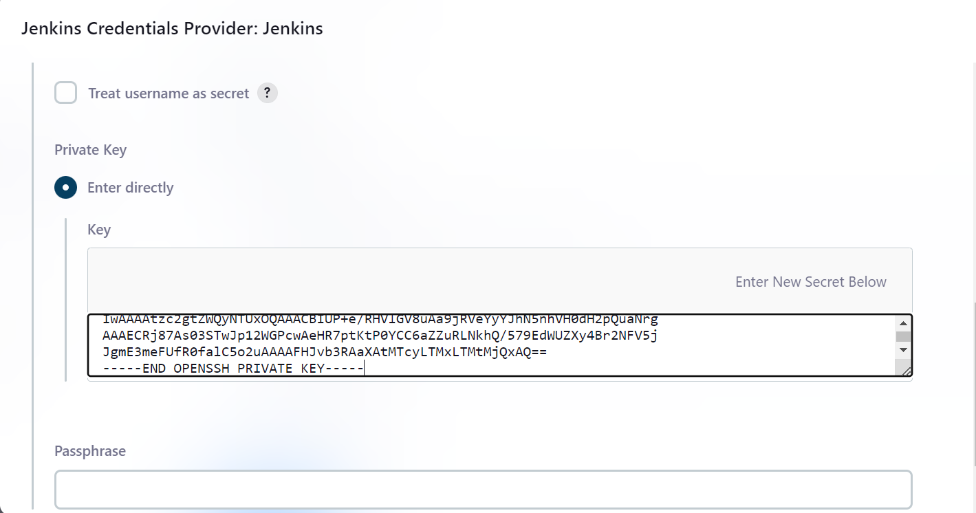

**Copy the private key from the server and add directly in the private key section and click on add**

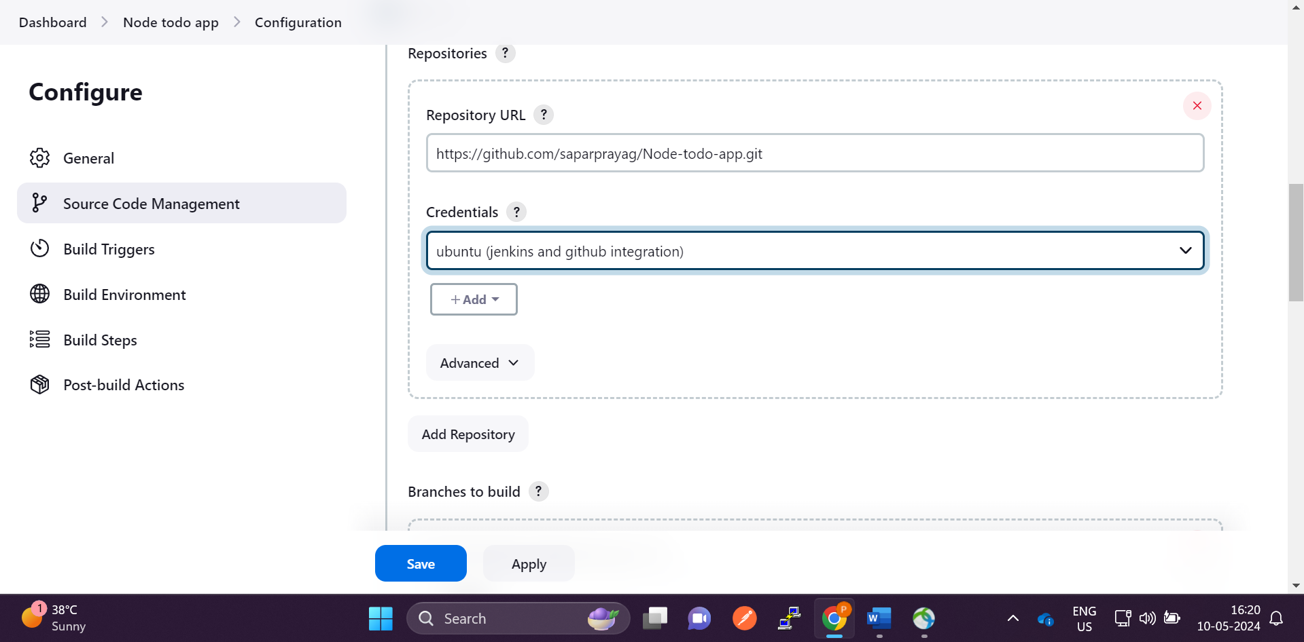

**Select the credentials from drop down menu.. If not visible from drop down menu … Go to manage jenkins ->Credentials-> there add the creds -> save -> select from drop down menu**

**Here we have integrated Jenkins with the github using ssh keys**

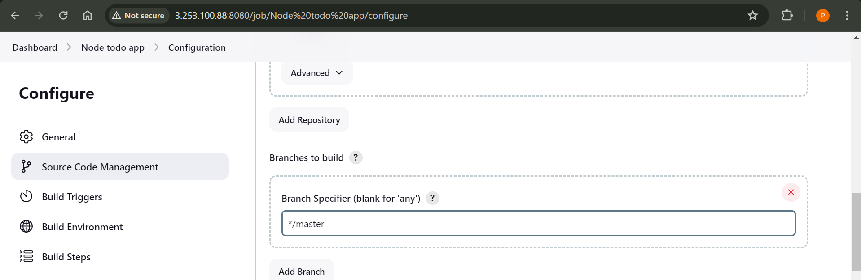

**Select the proper branch name and at bottom click on save**

**Now click on build now … to test wheather github and Jenkins are integrated or not**

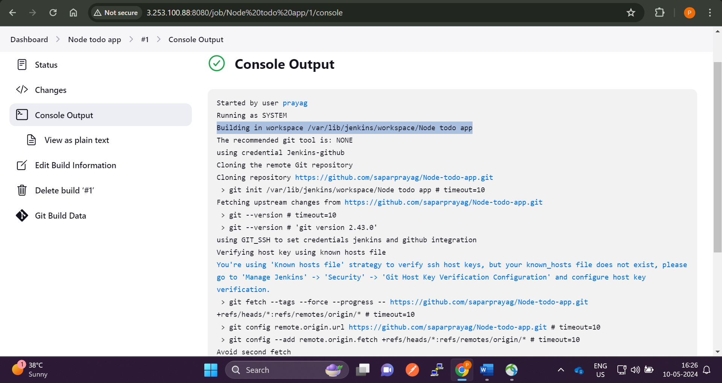

**Here in highlighted part Jenkins has created workspace that means jenkins has pulled code from github successfully**

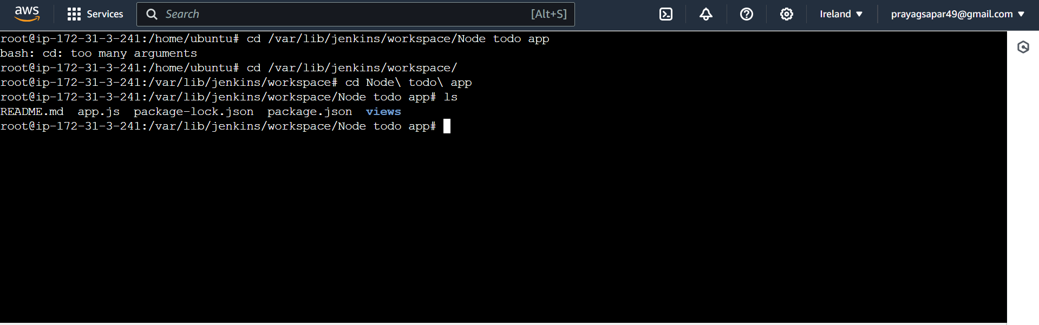

**As we can see that code is available in Jenkins workspace.**

**Now we will follow readme file provided by the developer and run the application and see**

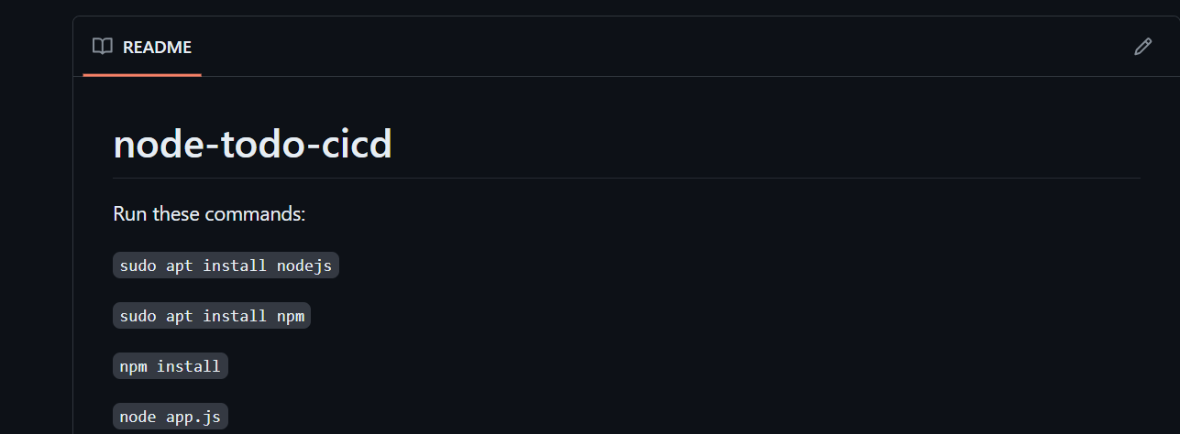

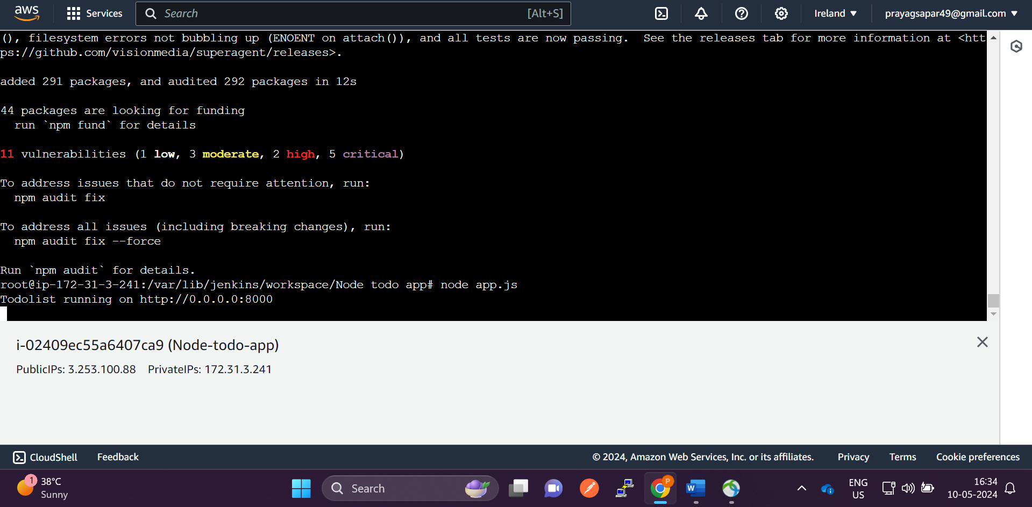

**We have tested the above read.md commands and application is running on port 8000**

**So we need to enable the port 8000 in the security group in order to access the application .. like this**

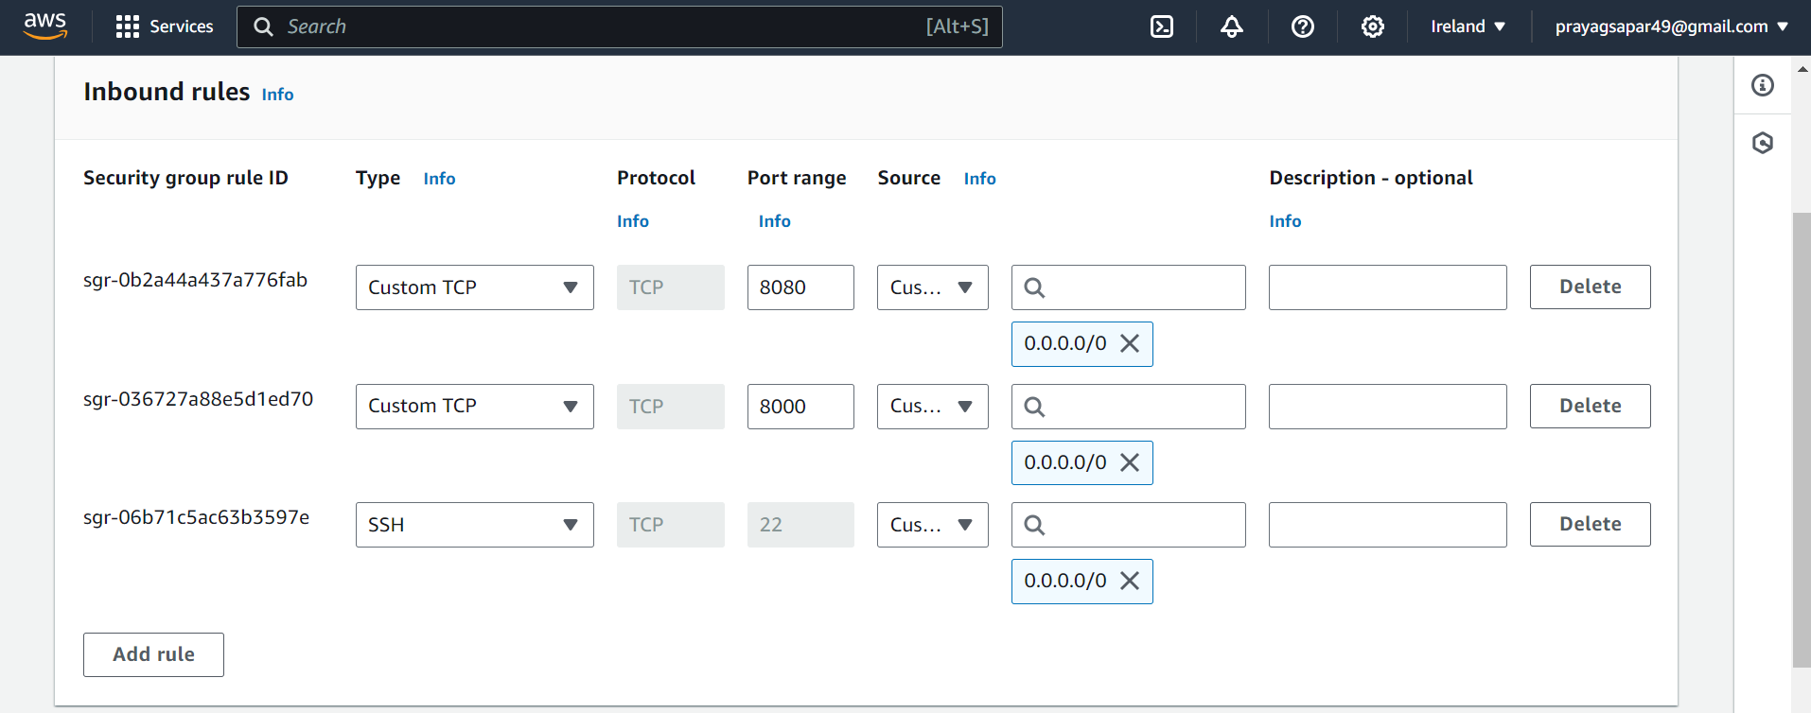

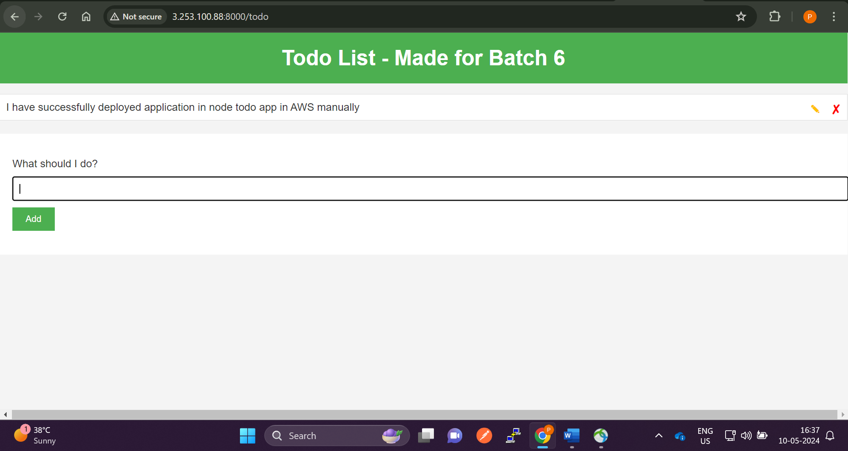

**Ya! Application is running fine… That developer has provided right readme.md file**

**Now we need to automate the installation using docker**

**Now we will make app such that it will run in any platform using docker !**

**Install docker command apt-get install docker.io**

**Whatever we have taken steps to install the application same we will define in the Dockerfile**

**1 update the os**

**2. copied the code from the git to the server**

**3. we intalled the required librarires to run the application**

**4. Then we exposed 8000 port so that we can access the application**

**5. Then we run the app using node app.js**

**We will automate the manual installation using the docker**

**We need to write the above steps in the docker file**

**Command vi Dockerfile**

**First we will install the os in which node is already installed**

**FROM node:12.12.0-alpine - This will install the os in which node is already installed**

**WORKDIR app - created a folder in which all work will be present**

**COPY . . - It copies the all the code files present in the server to the dockerfile**

**RUN npm install .. it will install the npm (dependencies)**

**EXPOSE 8000 ..It will expose the ip to 8000 so that the application runs on port 8000**

**CMD ["node","app.js"] .. It will the run the application using command node app.js**

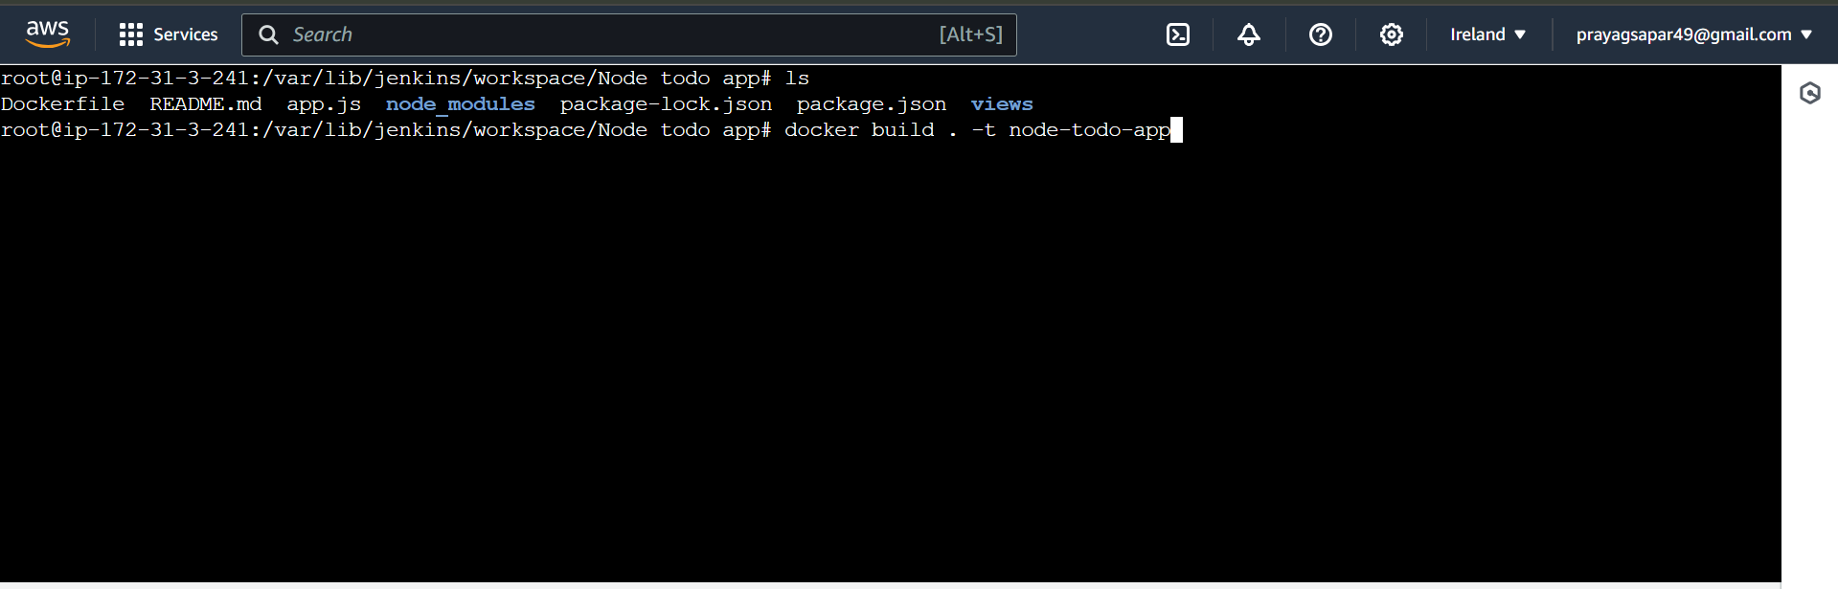

**Now we will create an image using docker build command**

**Command docker build .-t <tagname>**

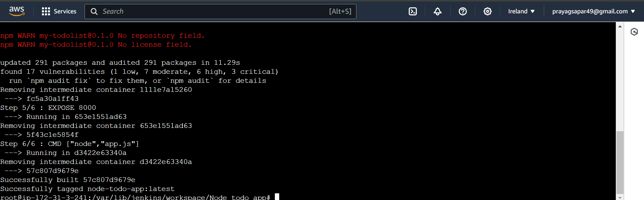

**Dockerfile is successfully build**



**We can see images by using docker images command**

**Now we need to run docker image and map the host port and docker build in order to run application in the docker container**

**docker run -d -p 8000:8000 <image-nmae>**

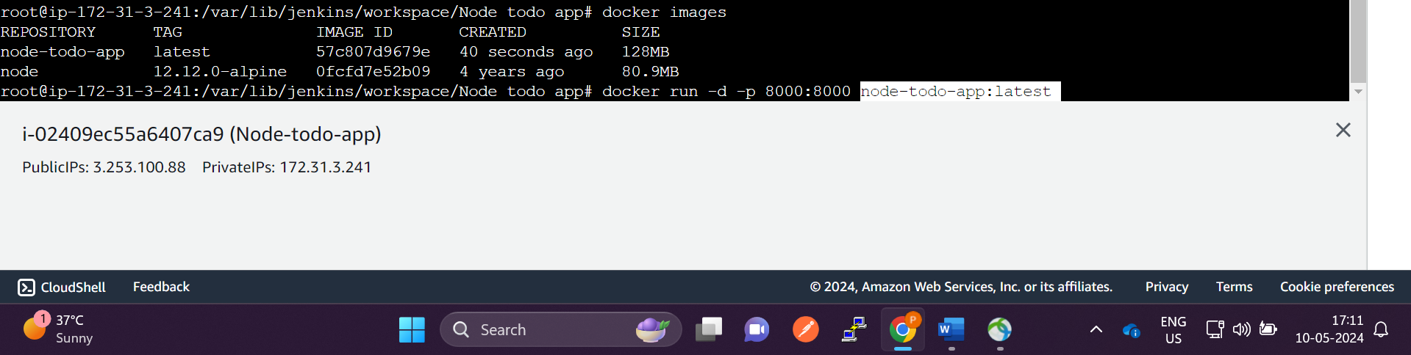

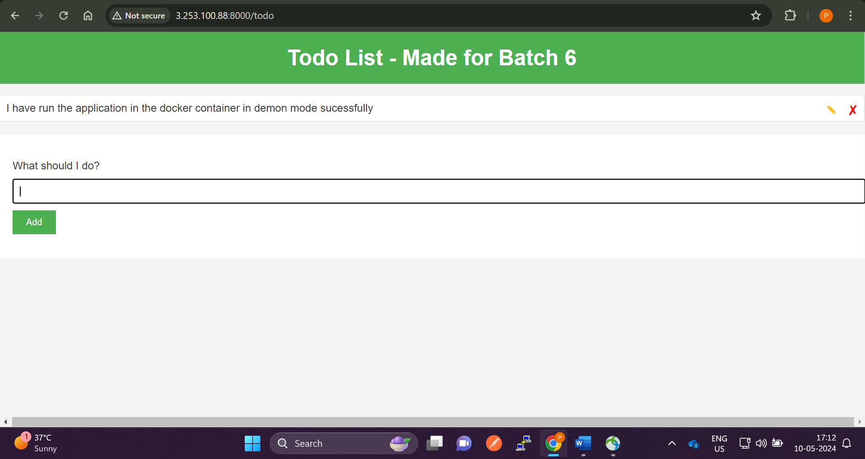

**Application is running now in the docker container.**

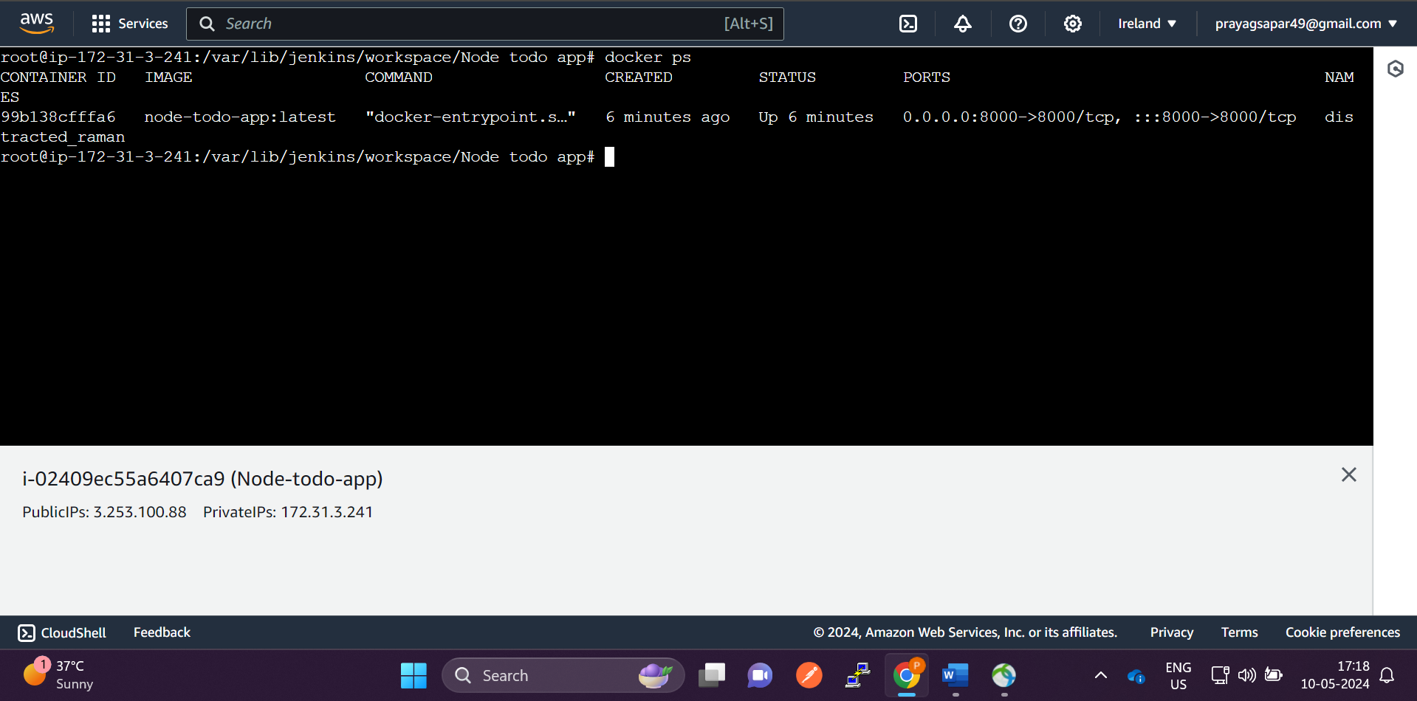

**docker ps command to check the running containers…**

**Now we will run the application using docker container using the Jenkins**

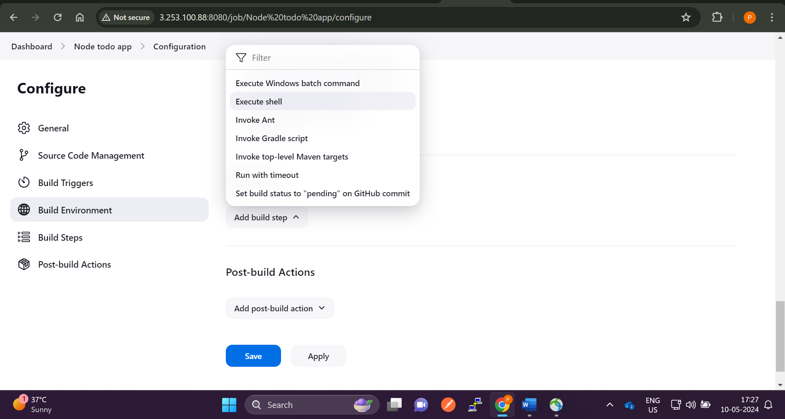

**Now go to the Dashboard -> node app -> configure – build steps and select execute shell**

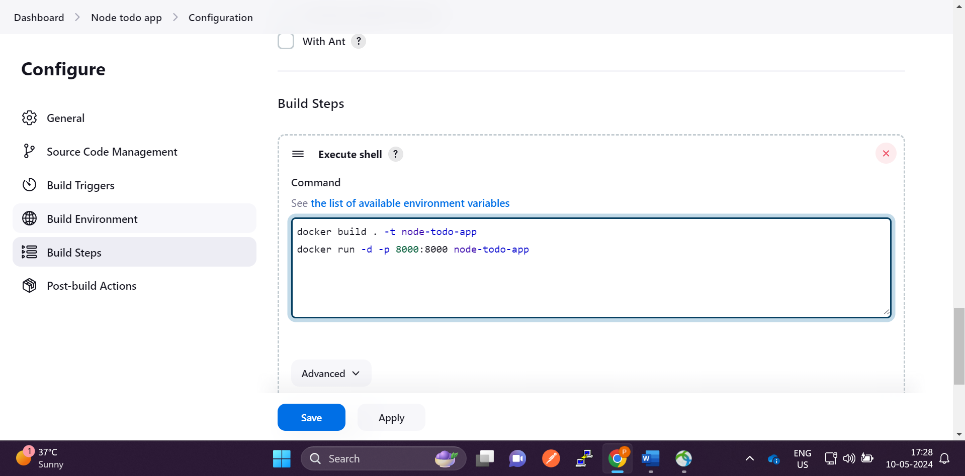

**Type the above commands … and save it .. make sure that Dockerfile is present in the github**

**If not push it to github**

**whatever we have manually entered the commands we will enter it in Jenkins execute shell so the dockerfile will build automatically**

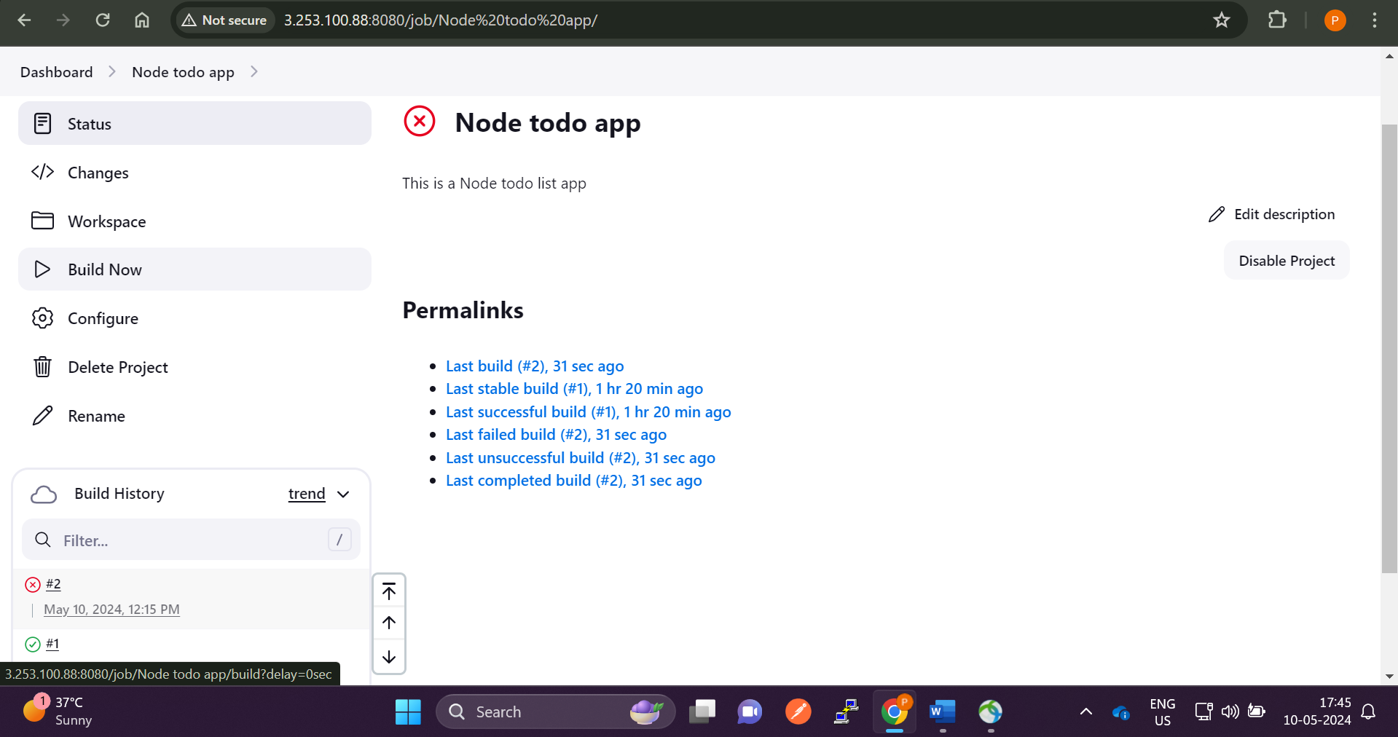

**Click on build now**

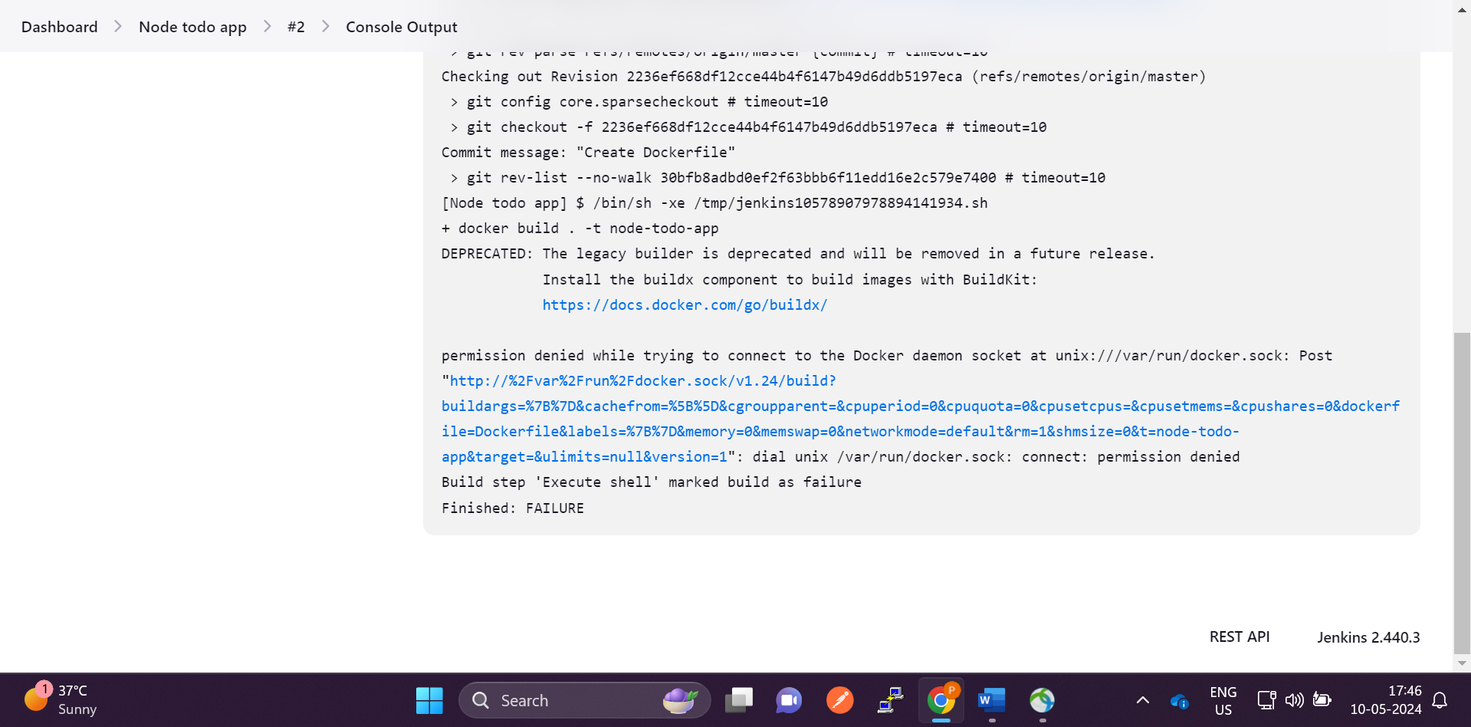

**We will face an error permission denied .. to solve this we need to**

**Do this :**

**go to -> cd** /var/lib/jenkins/workspace/cicd – (where Jenkins has all project code)

**Add this command 🡪 sudo chmod 666 /var/run/docker.sock**

**After this click on buildnow ..now the pipeline will build successfully.**

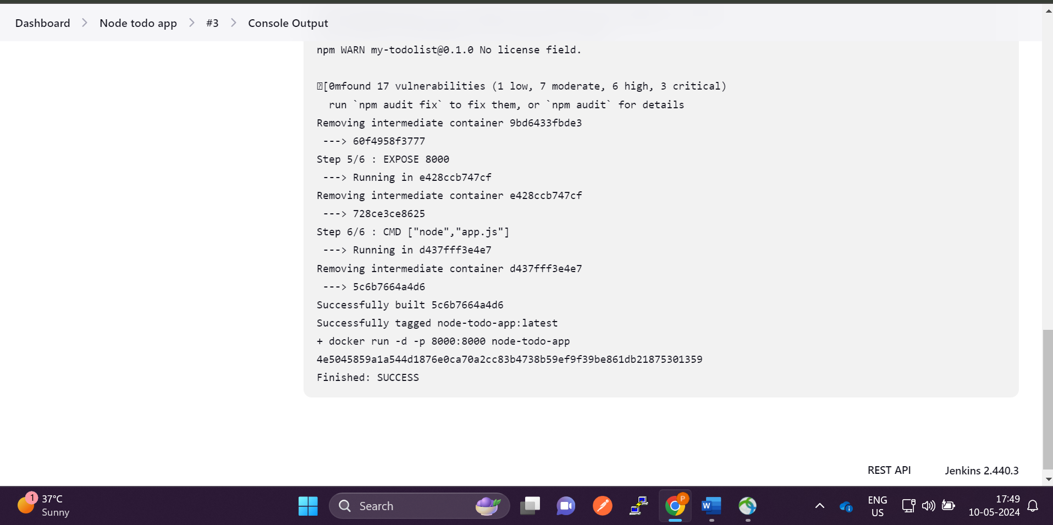

**Build has successfully executed**

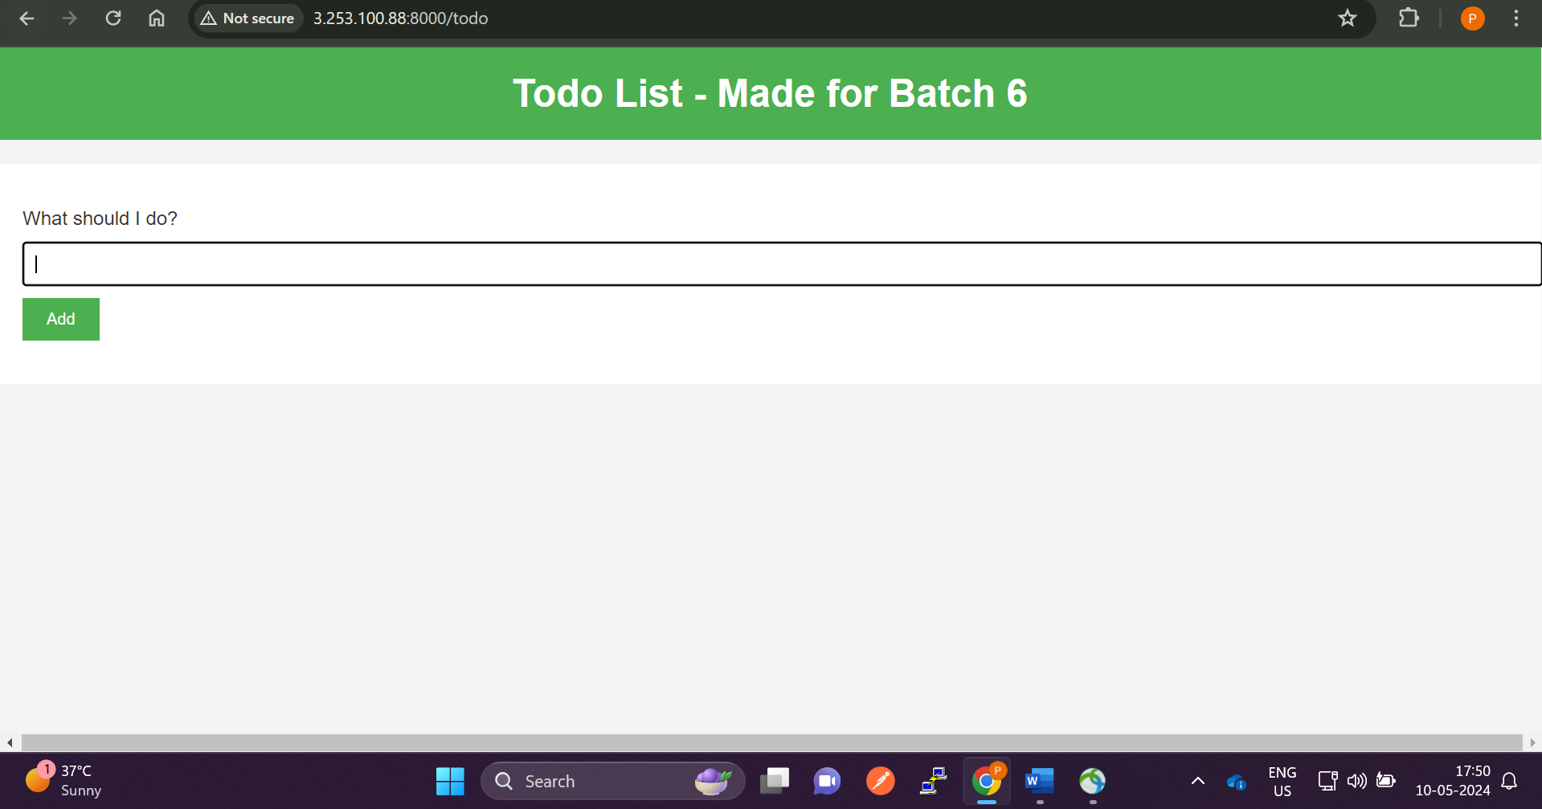

**We have run the application in the docker container using Jenkins.**

**Till now we we continuously clicking the buildnow button … that means we are doing continuous integration and continuous deployment ..**

**We will setup github-webhooks and integrate it with Jenkins to auto trigger the pipeline**

**That means whenever developer modifiles the code Jenkins will automatically build the pipeline… we don’t have to press build now button.**

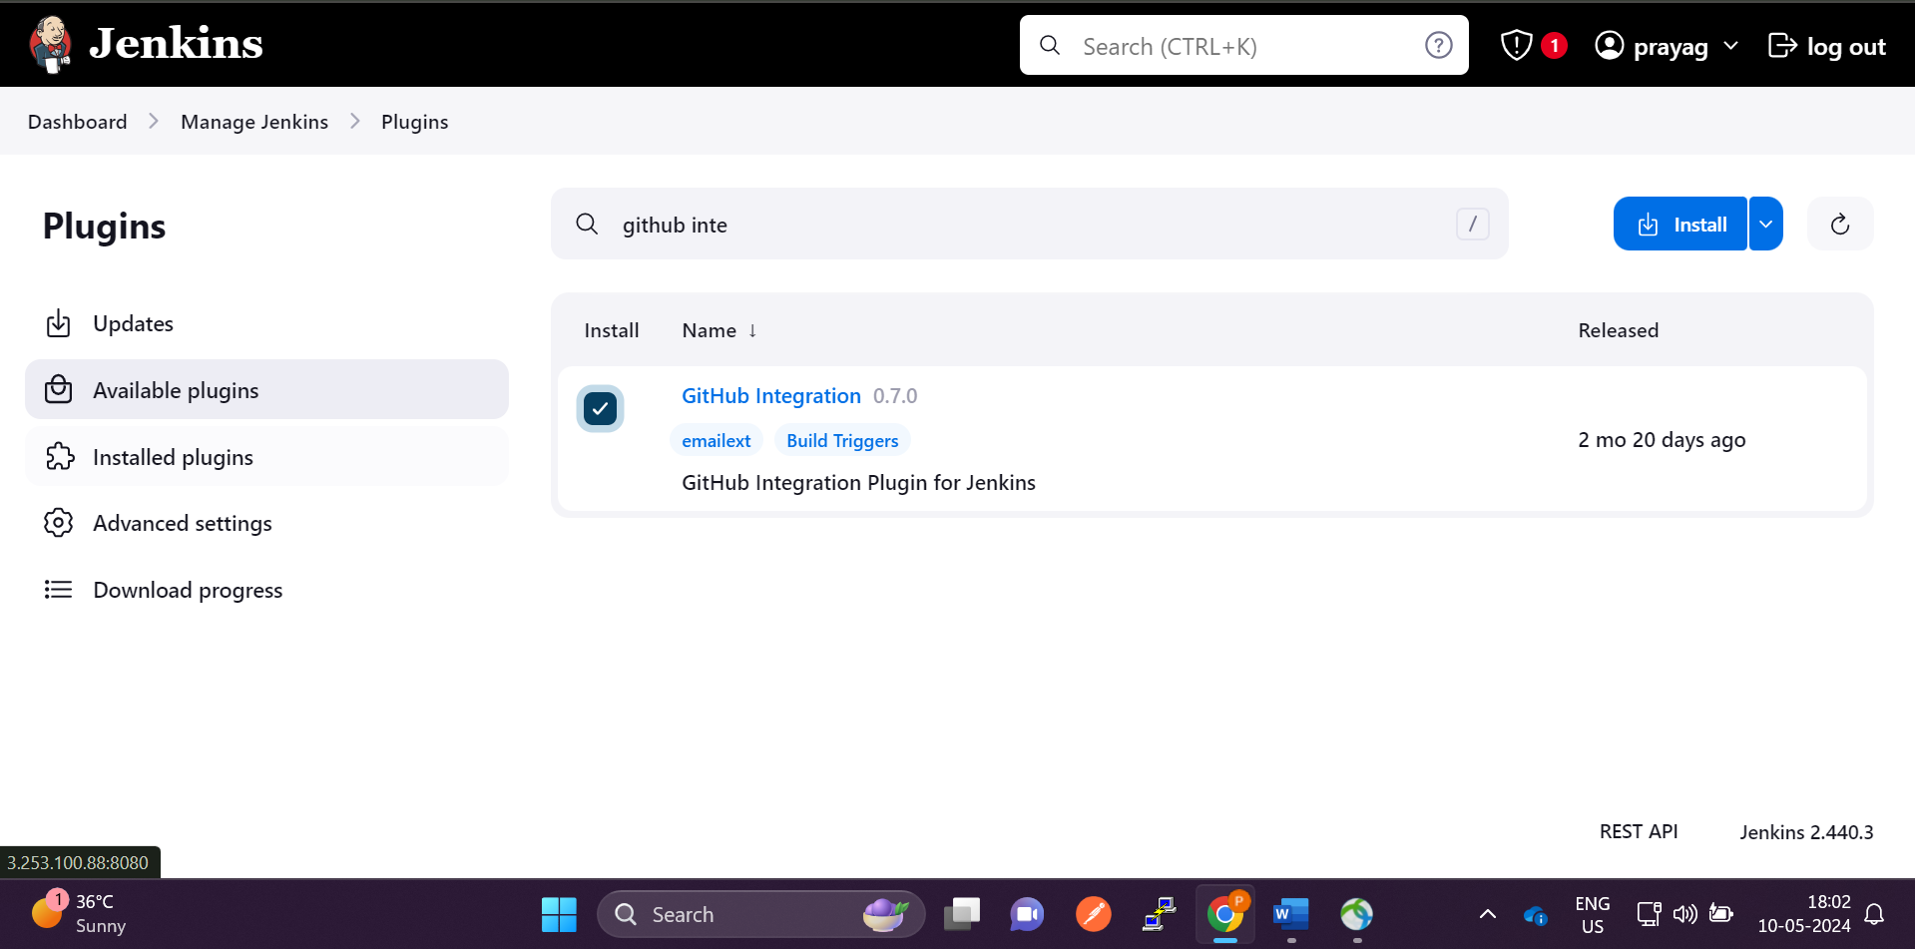

**First add this plugin in Jenkins and restart the jenkins**

**Go to github**

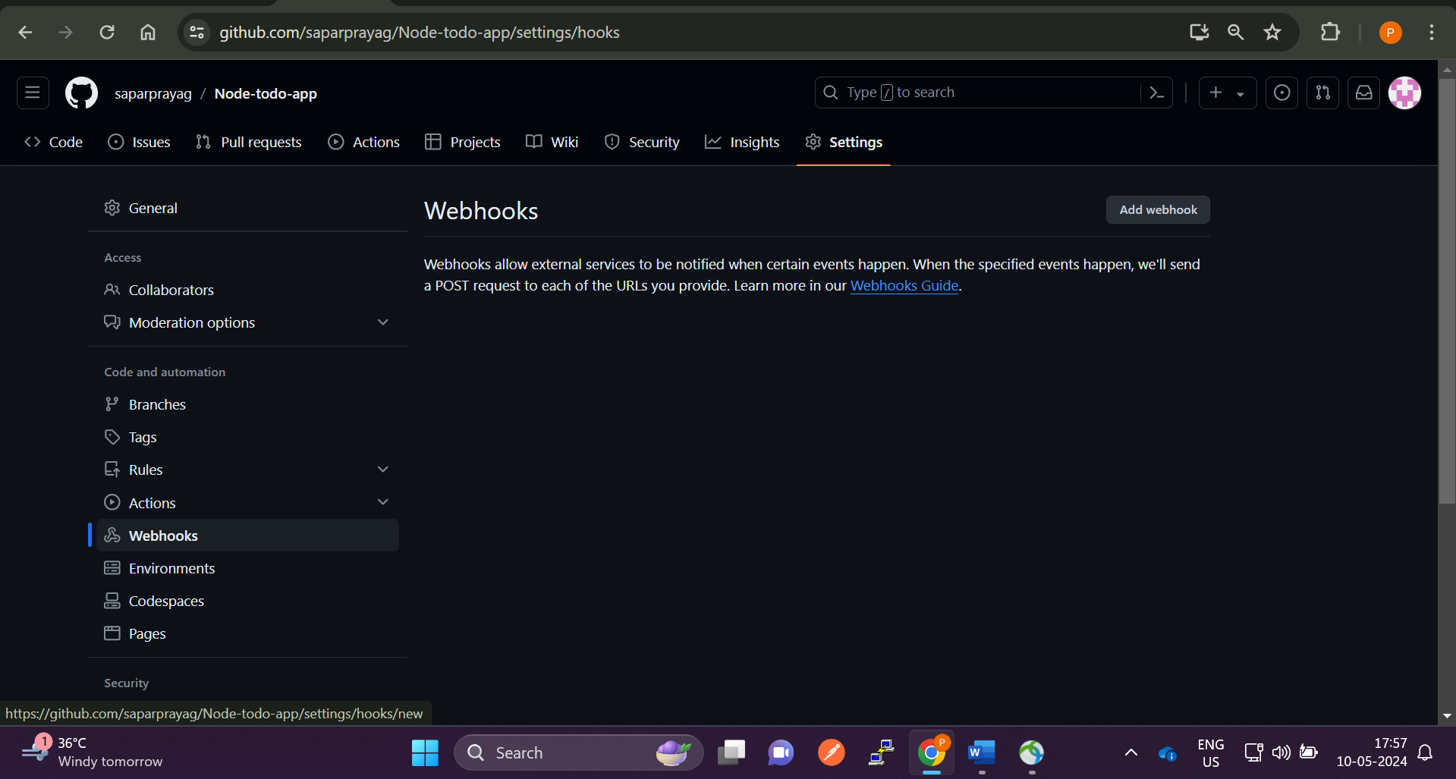

**Go to repository settings -> Webhooks -> click on add webhooks**

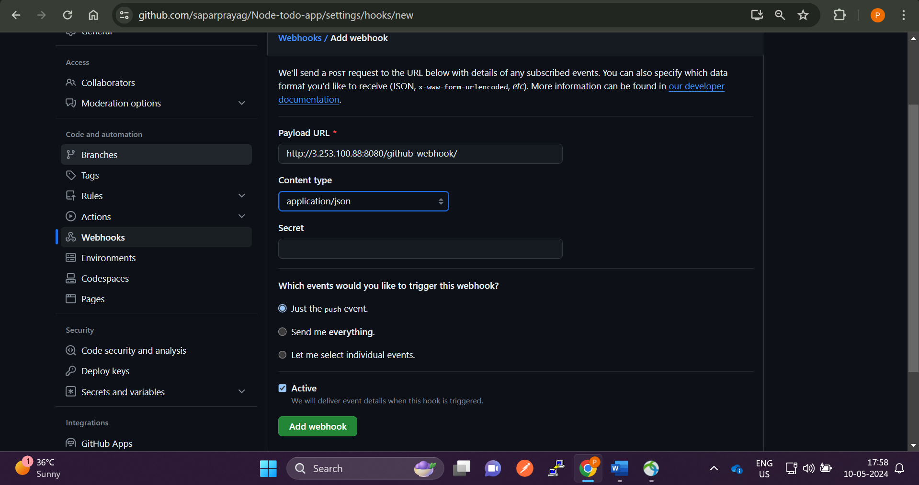

**In payload url give the <EC2-instance-ip:8080/github-webhook/**

**8080: Jenkins port number**

**And click on add webhook**

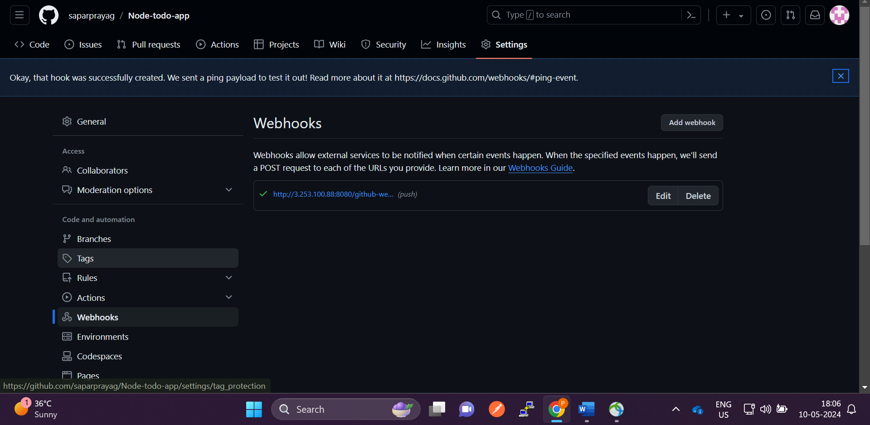

**We can see the green tik … that means webhook is added successfully**

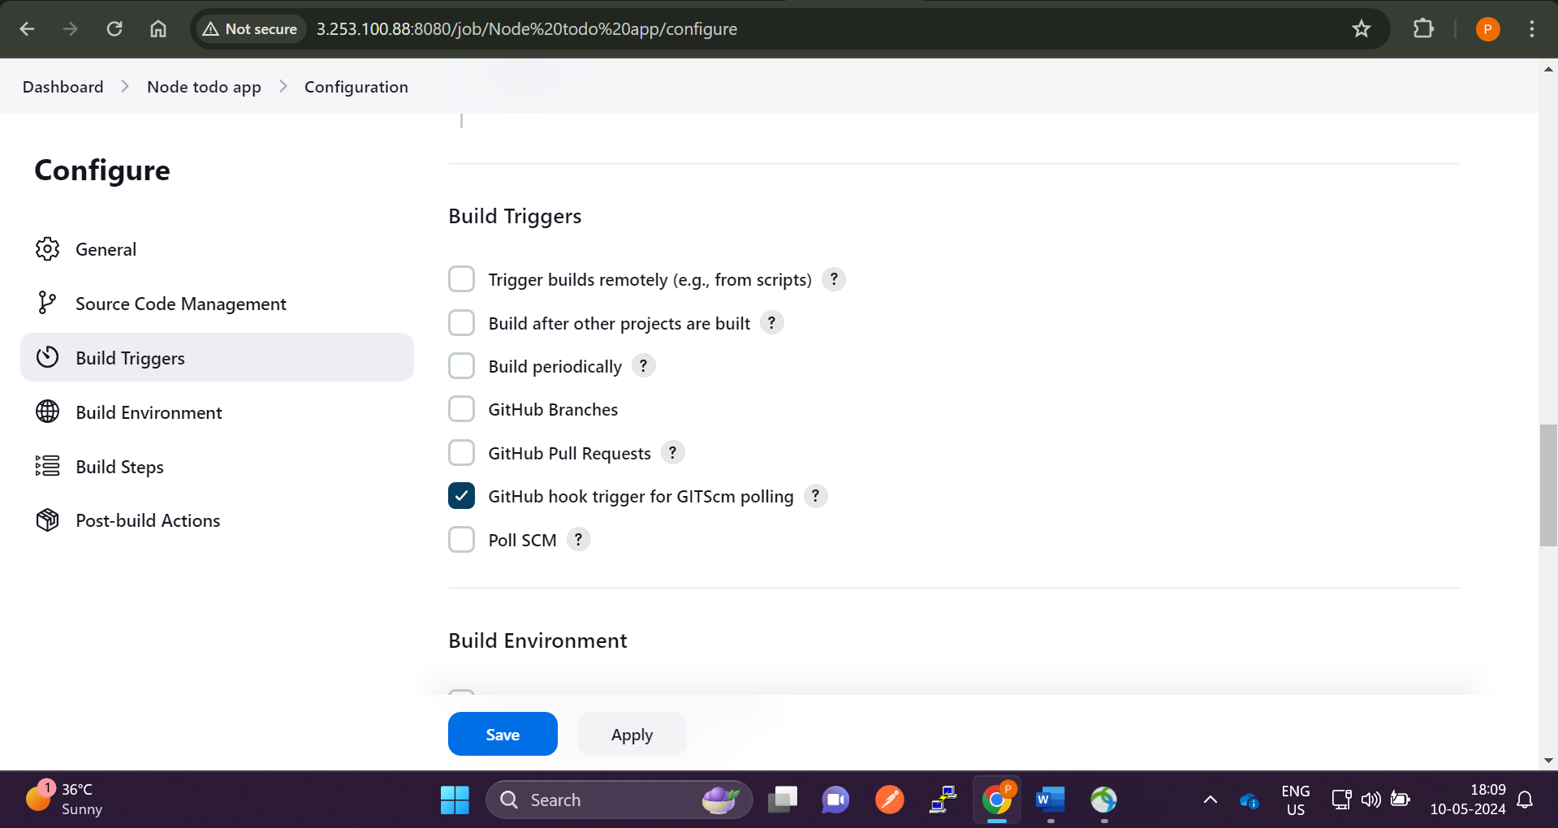

**Go to Jenkins and in build triggers check the** GitHub hook trigger for GITScm polling

Now webhook is successfully configured

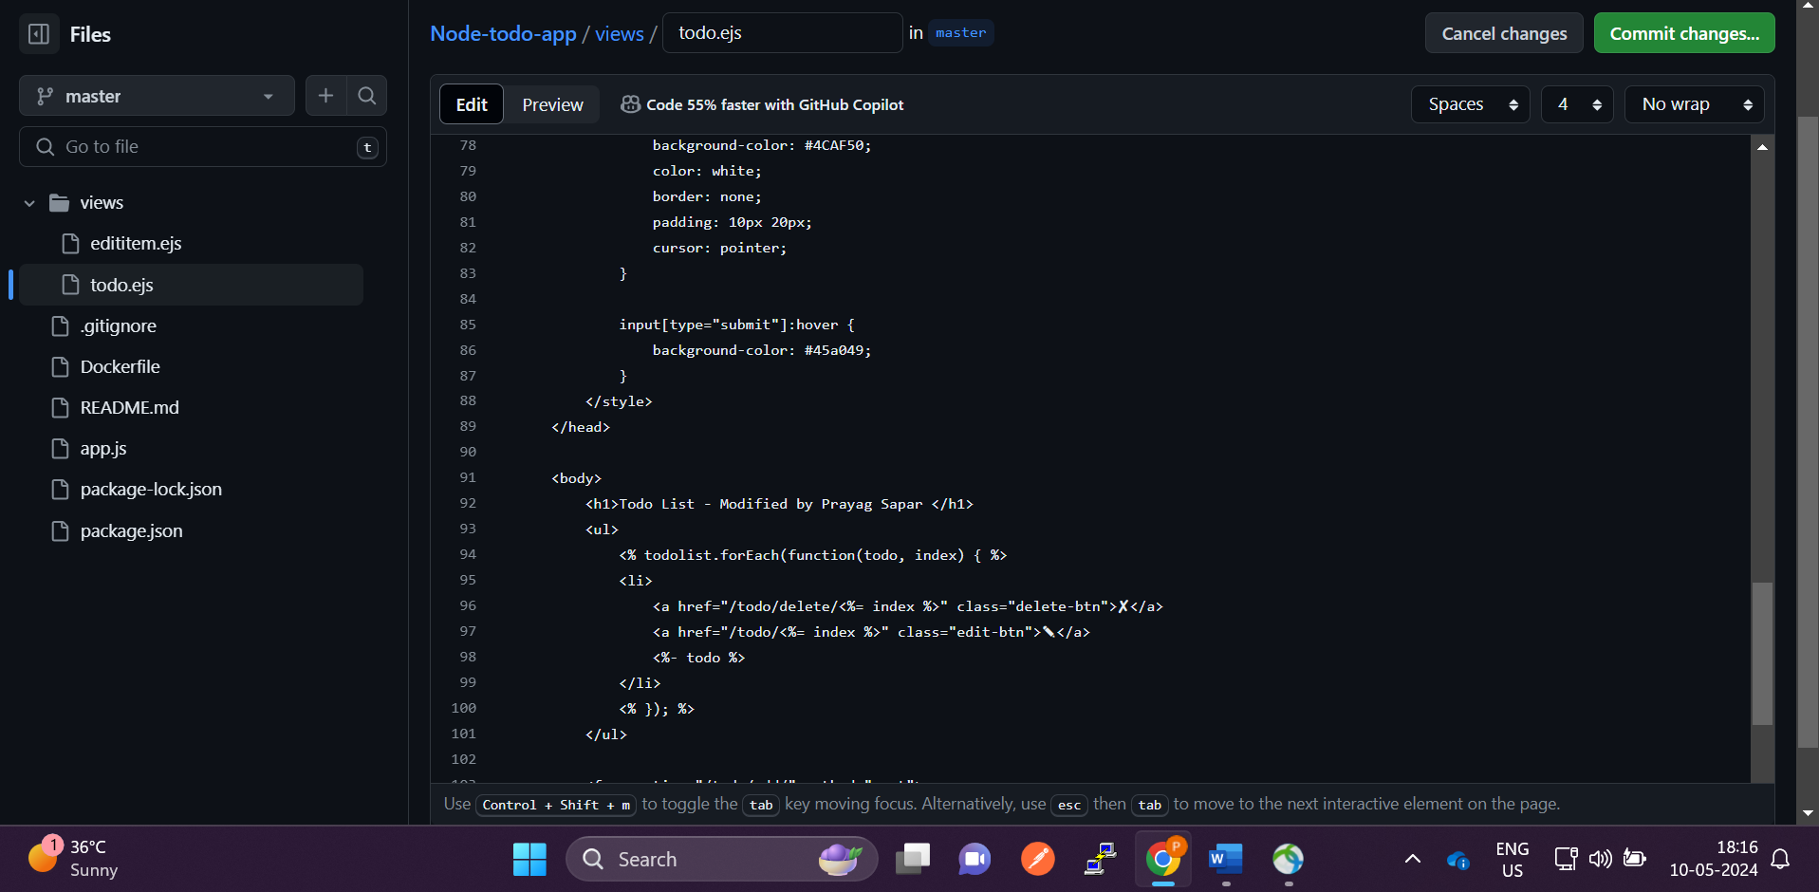

**Changes made in the code**

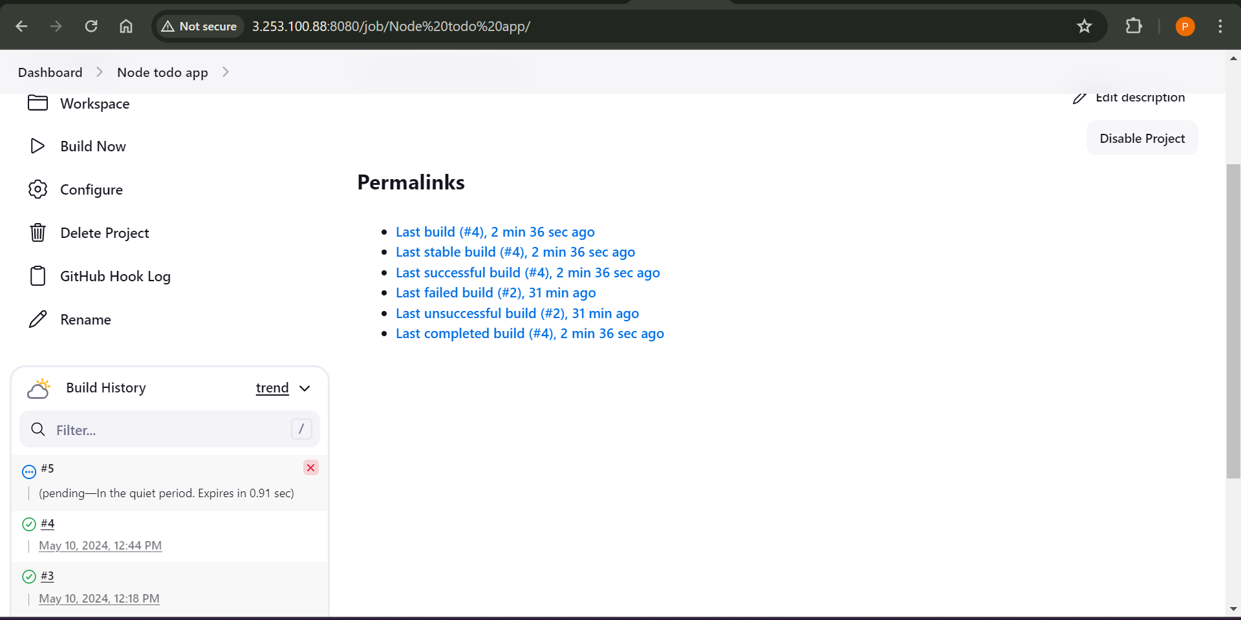

**Jenkins pipeline automatically triggered**

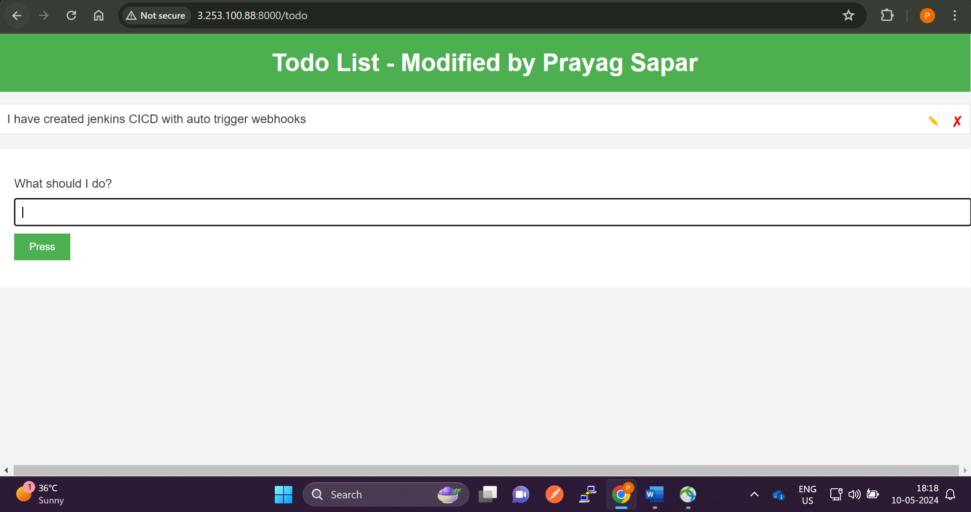

**Jenkins pipeline successful CICD**

**Now we will use docker compose to kill the container automatically and run the container**

**Install the docker-compose using below commands**

**sudo apt remove docker-compose**

**wget https://github.com/docker/compose/releases/download/v2.24.1/docker-compose-linux-x86_64**

**chmod +x docker-compose-linux-x86_64**

**sudo mv docker-compose-linux-x86_64 /usr/bin/docker-compose**

**docker-compose –version**

**now we will create a docker-compose.yml file and write the logic**

**vi docker-compose.yml and paste the below commands**

**version: "3.3"**

**services:**

**web:**

**build : .**

**ports :**

**- "8000:8000"**

**After this make the container up using docker-compose up -d**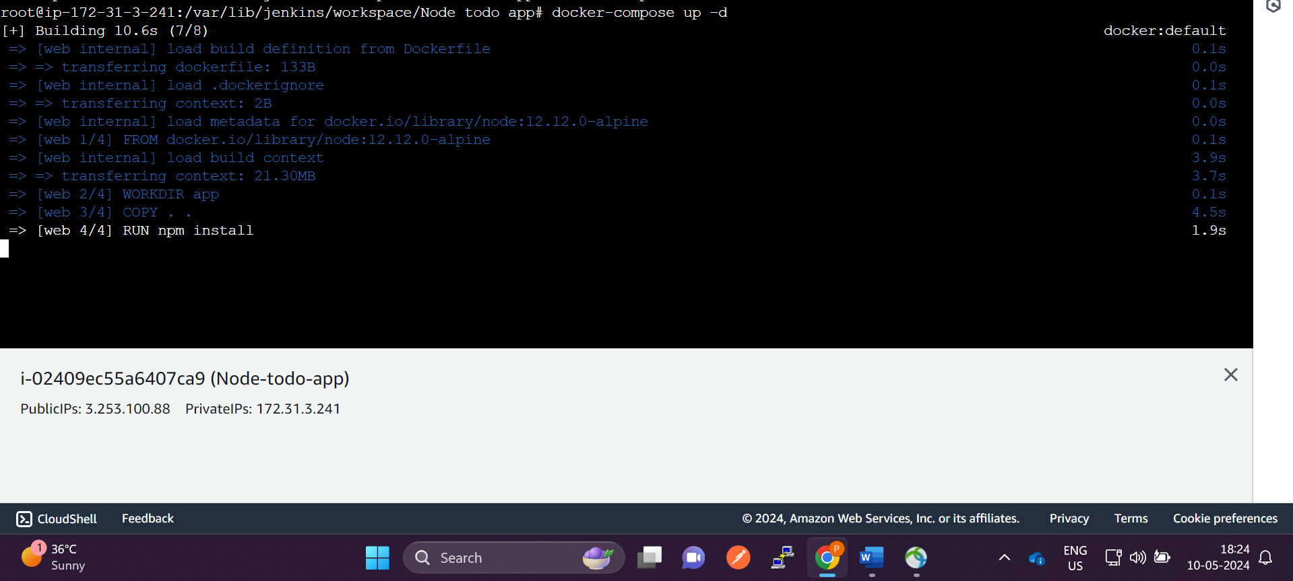

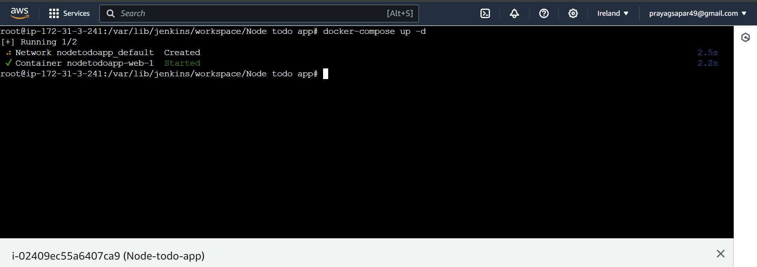

**Docker-compose is running fine**

**We have to just use docker-compose up -d … to run the container**

**And docker-compose down … to kill the container**

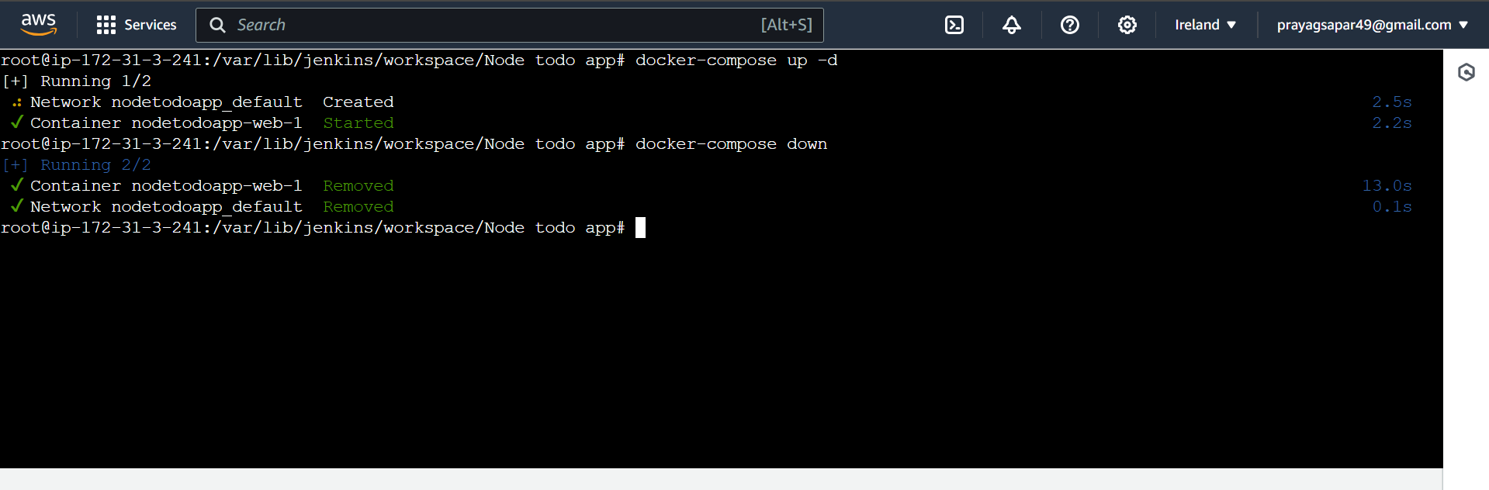

**Lets automate it using Jenkins now !**

**Now we will use docker-compose with Jenkins**

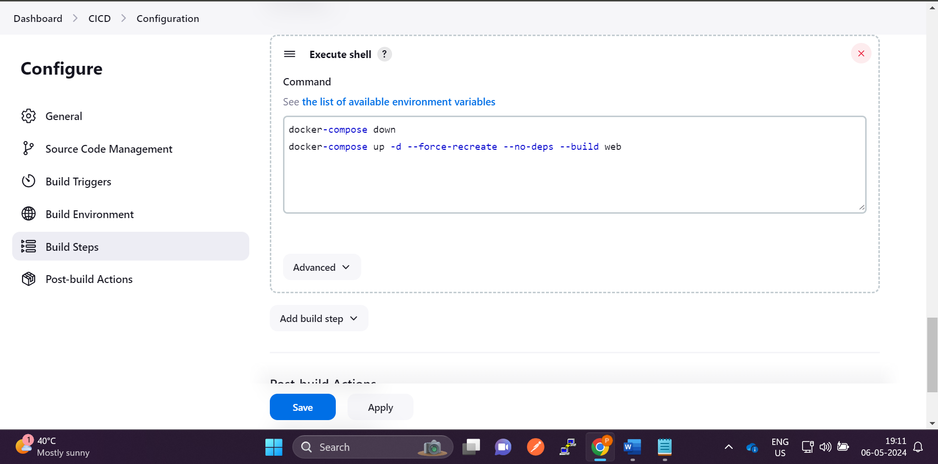

**First it will destroy the container… so that we wont get error i.e port is already in use.**

**Then it will run the container and forcefully recreate it with no dependencies and build the app called web service in case of docker compose. Which will build the image automatically.**

**version: "3.3"**

**services:**

**web: …. This service**

**build : .**

**ports :**

**- "8000:8000"**

**Now Implement Jenkins declarative pipeline**

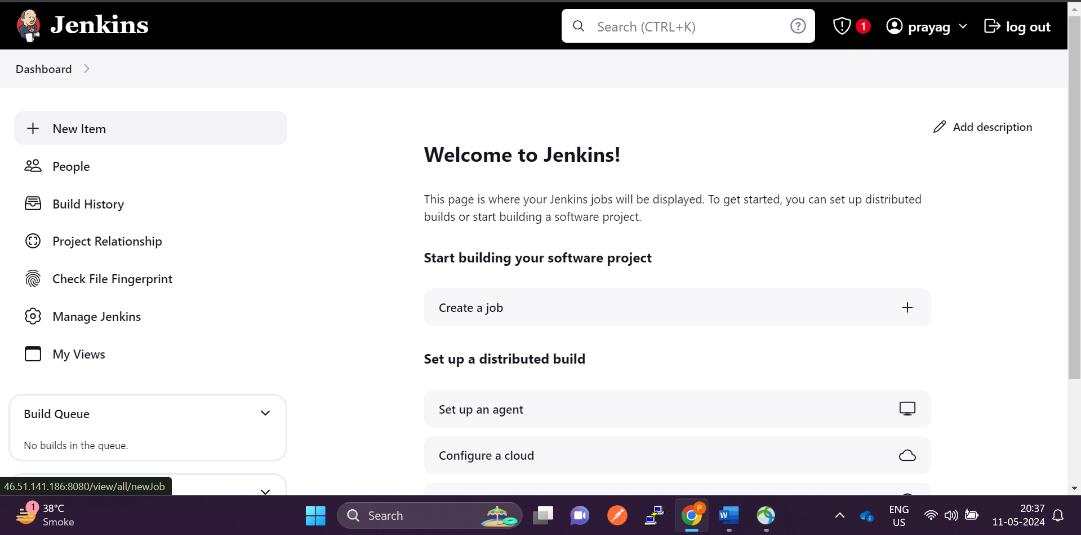

**Click on new item**

**And select the pipeline app**

**And the github url**

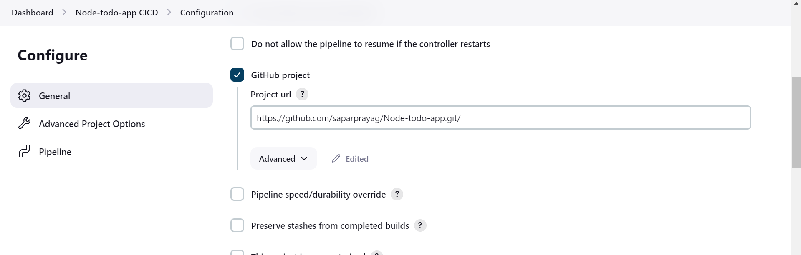

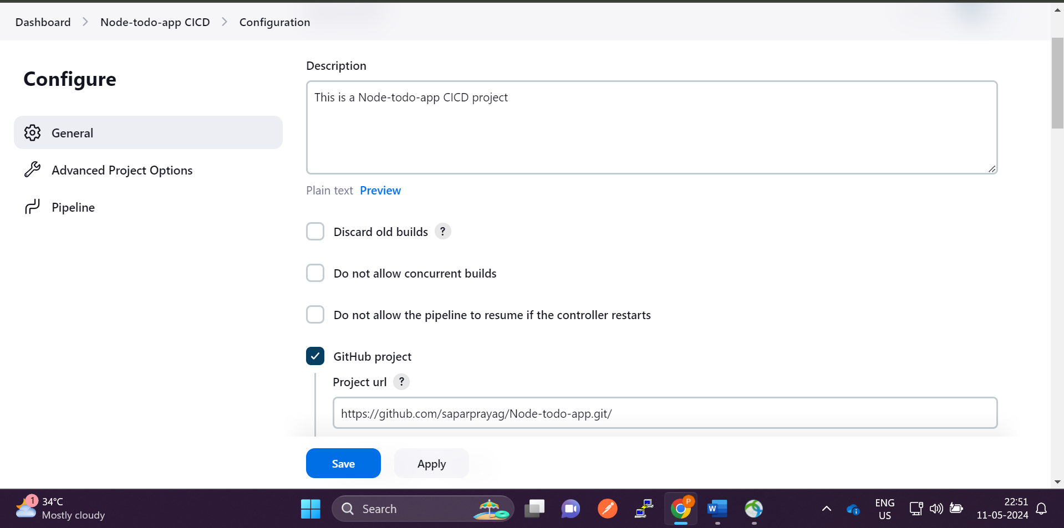

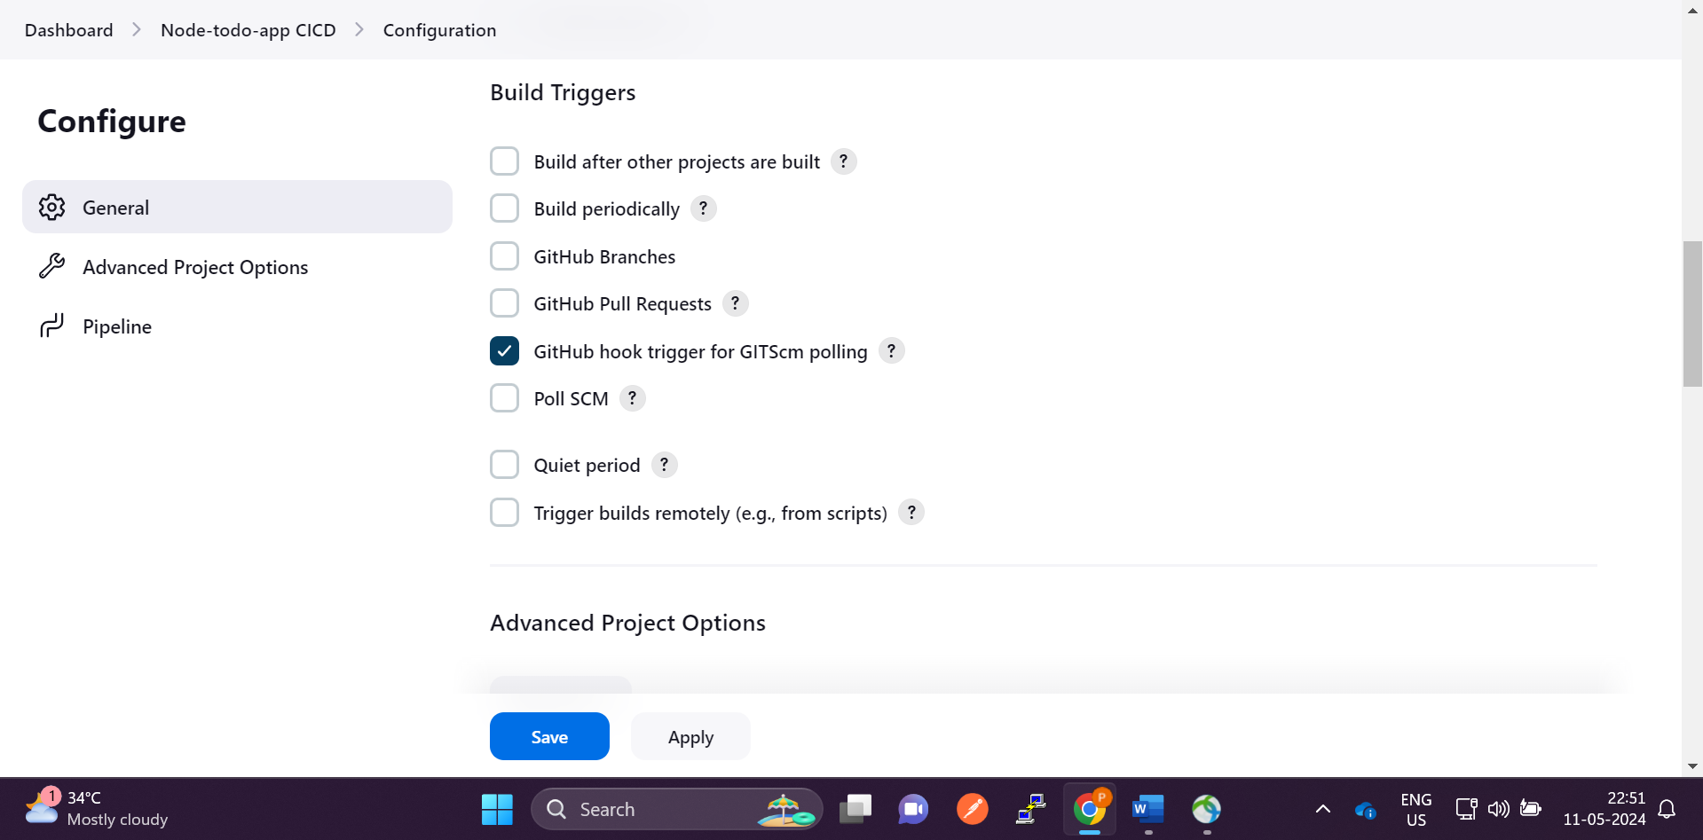

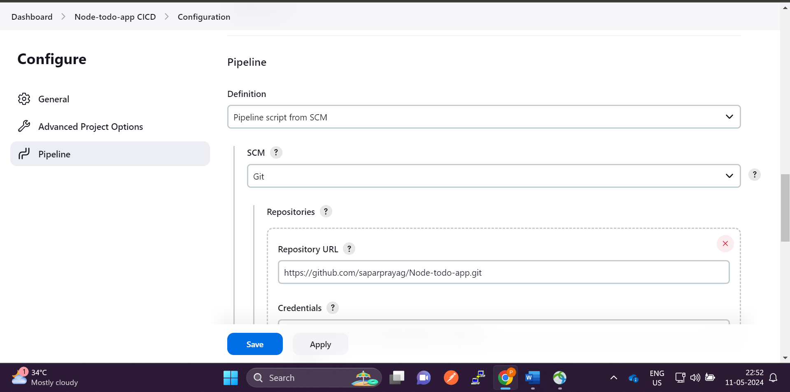

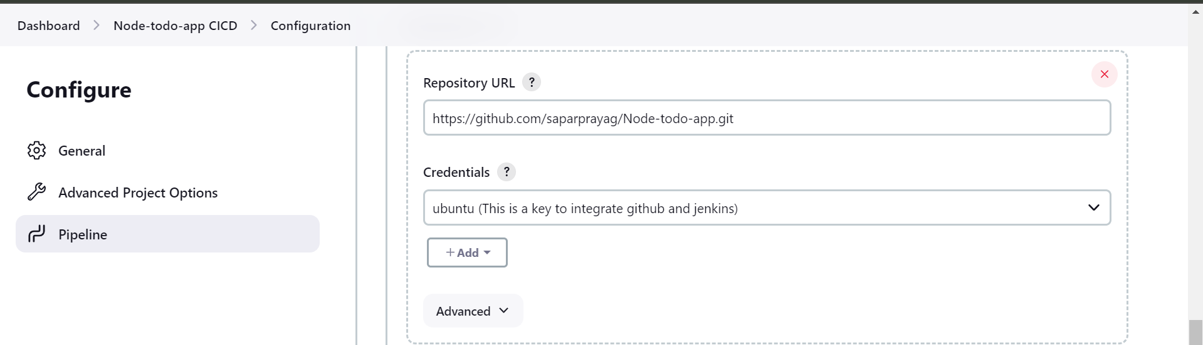

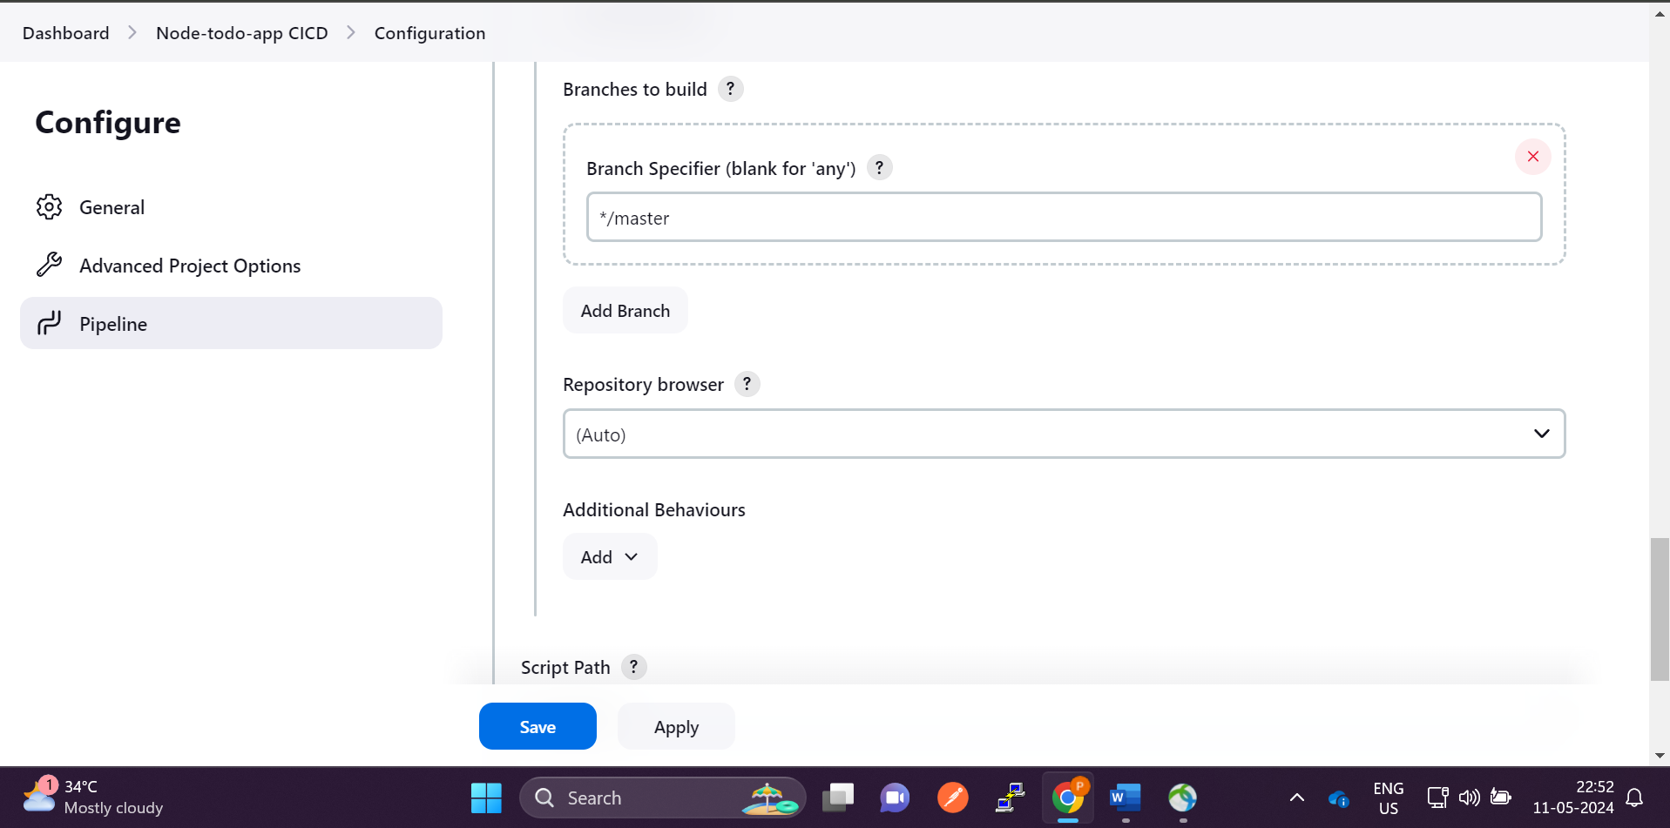

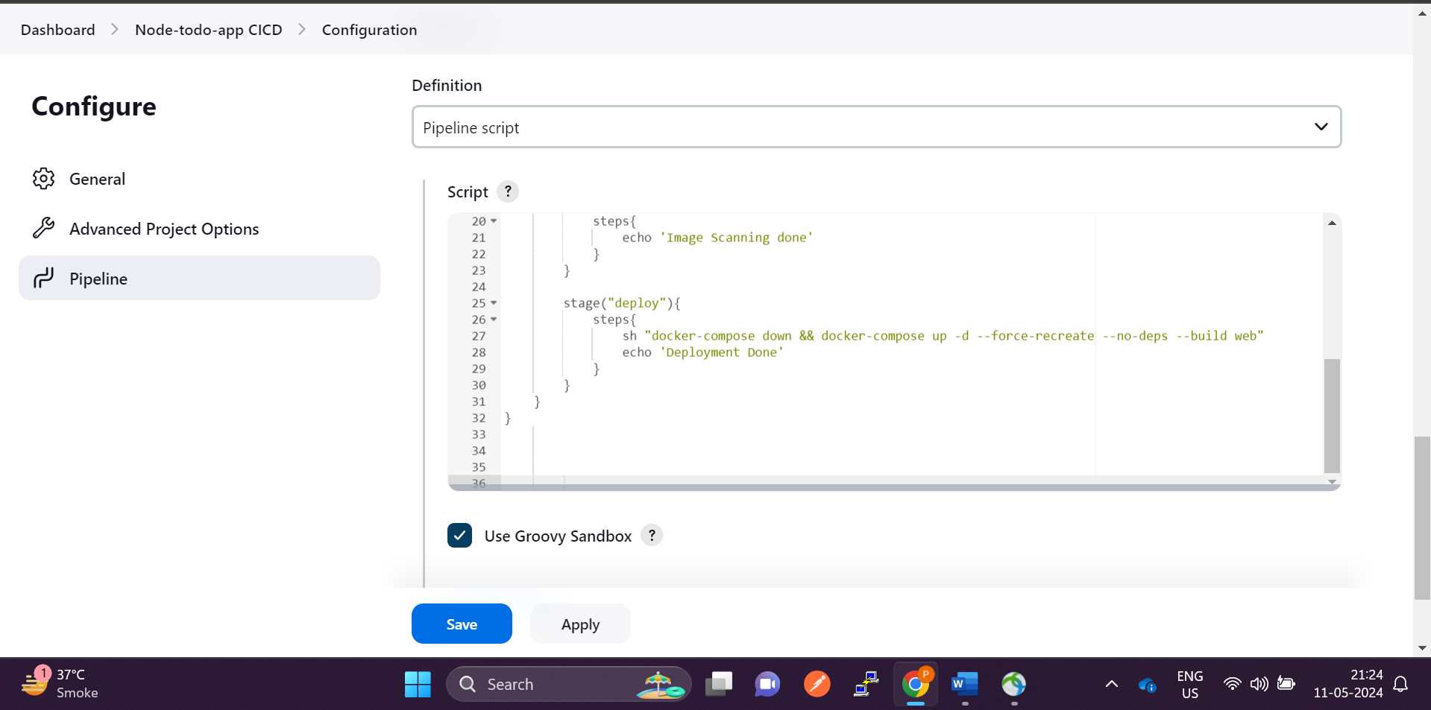

**Add the pipeline script**

**pipeline {**

**agent any**

**stages {**

**stage("code"){**

**steps{**

**git url: "https://github.com/saparprayag/Node-todo-app.git", branch: "master"**

**echo 'Code cloned successfully'**

**}**

**}**

**stage("Build and test"){**

**steps{**

**sh "docker build -t node-todo-app ."**

**echo 'Code building done'**

**}**

**}**

**stage("scan image"){**

**steps{**

**echo 'Image Scanning done'**

**}**

**}**

**stage("deploy"){**

**steps{**

**sh "docker-compose down && docker-compose up -d --force-recreate --no-deps --build web"**

**echo 'Deployment Done'**

**}**

**}**

**}**

**}**

**This is good… But we can do more better by adding pipleline as SCM**

**Copy the above code and go to the github**

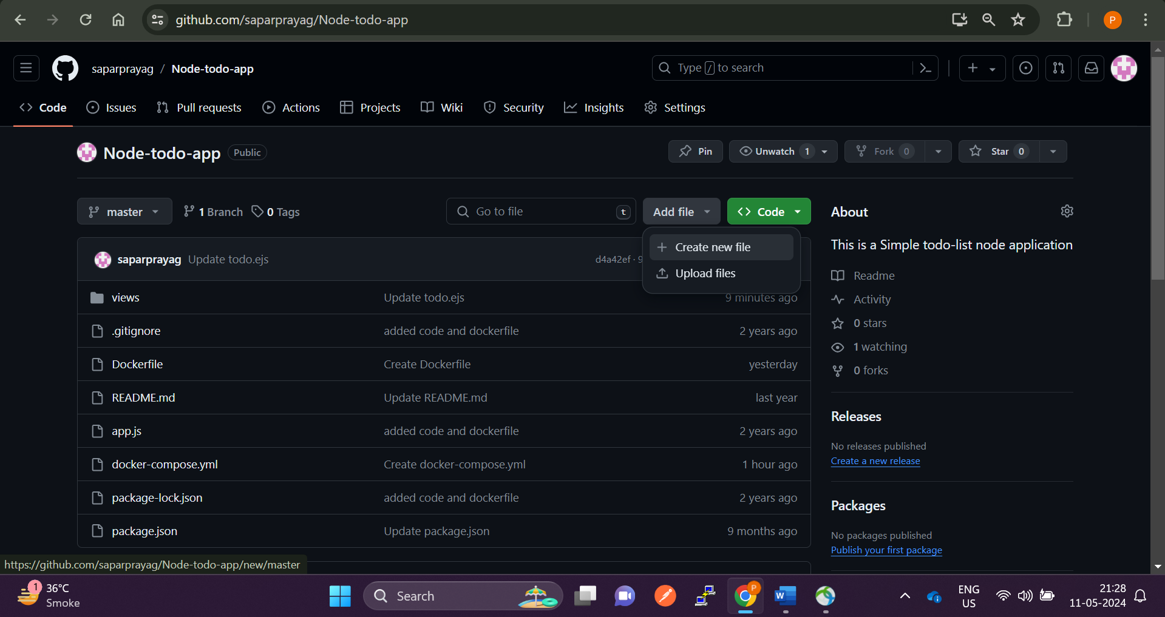

**Create a new file “Jenkinsfile” note that “J” should be capital**

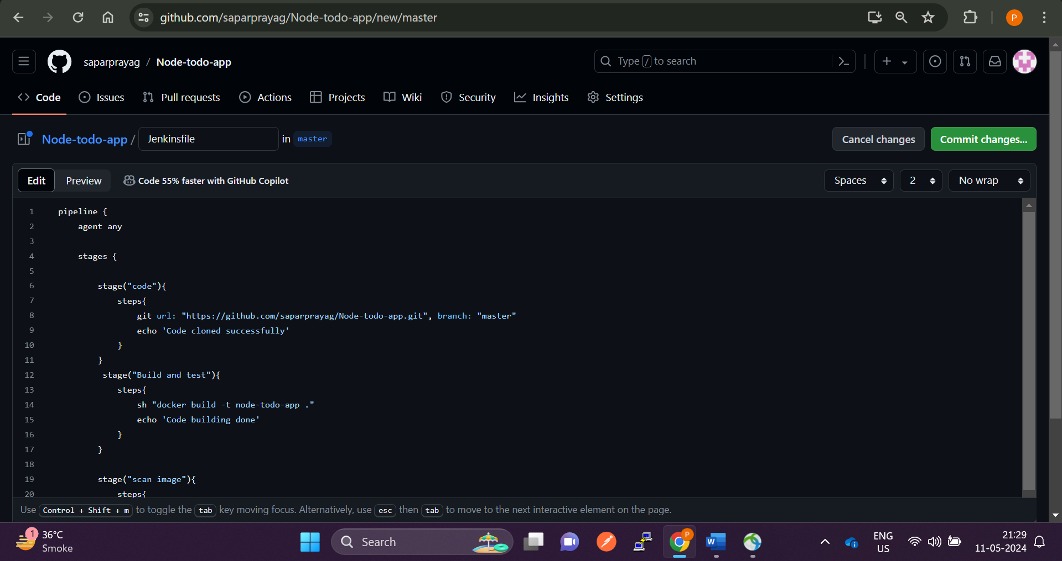

**And paste the code. And commit the changes**

**Now go to the Jenkins and select pipeline from Source code management**

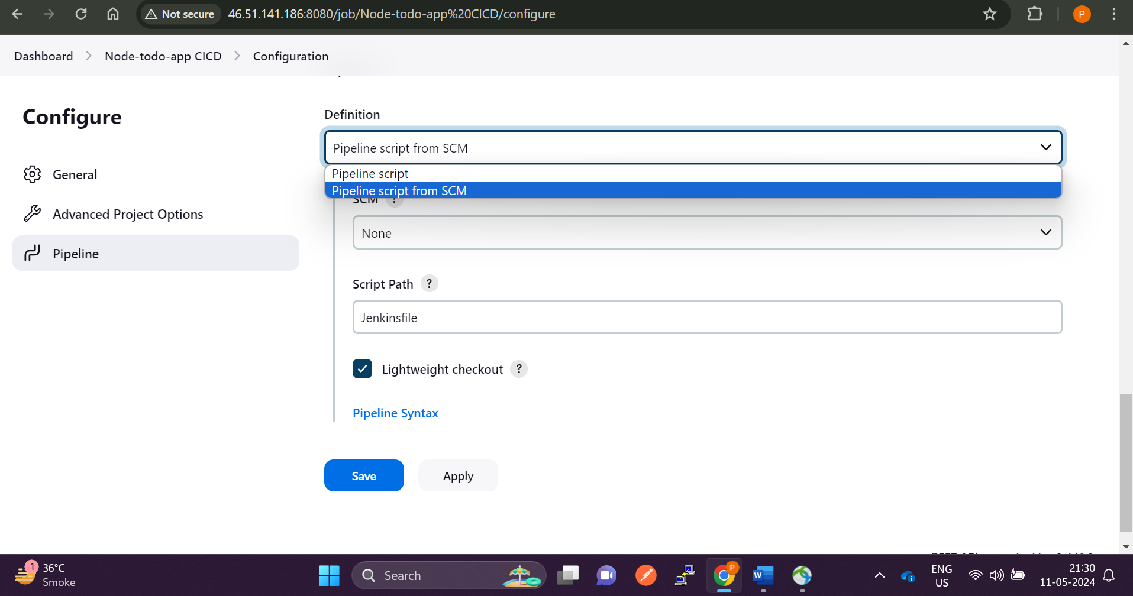

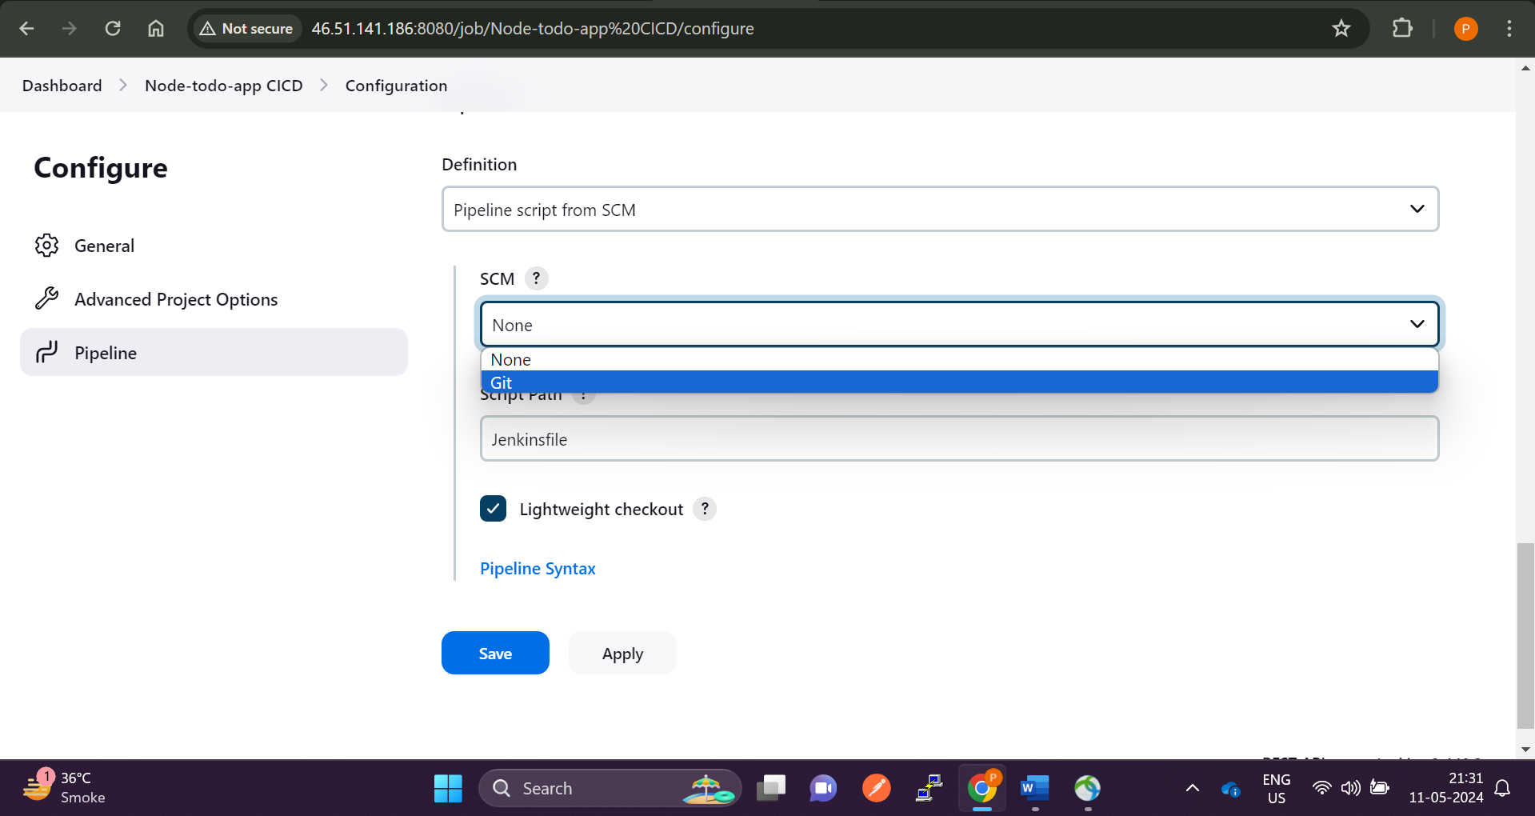

**Select scm as git and click on save**

**Now modify the github code Jenkins will trigger the pipeline automatically**

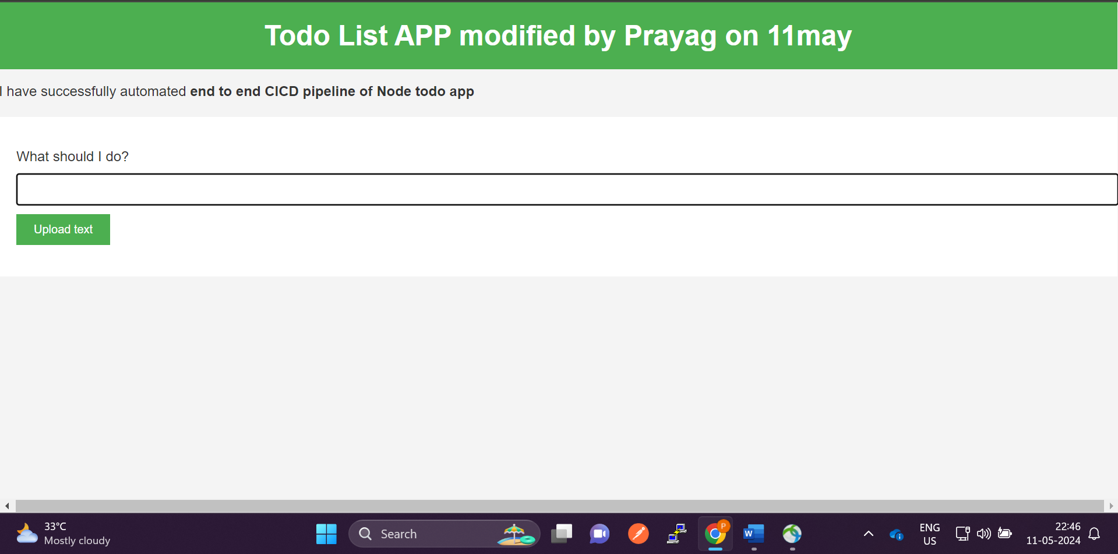

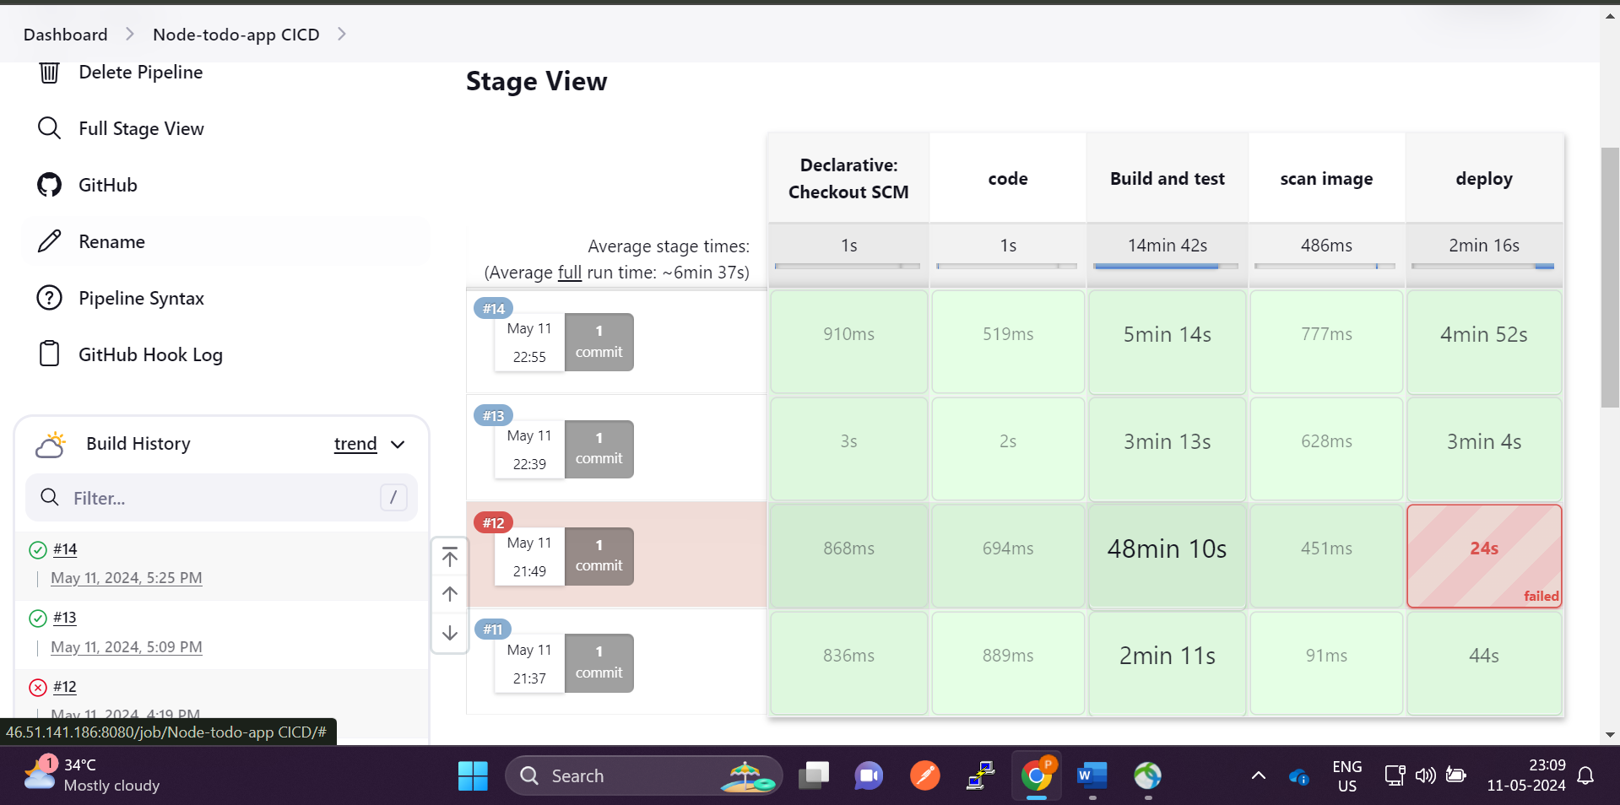

**We have successfully created an automated end to end CICD pipeline with webhook integration**

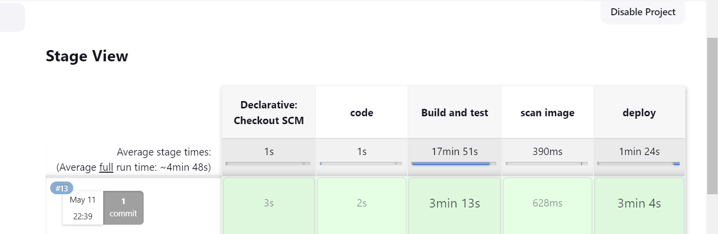

**Jenkins configuration**











